Part one: New words. Write down the characters with pinyin and meaning in English.
pinyin | Characters: you must write the characters in the correct orders. |  |  |  |  |  |  |  | English Meaning
 | 前 | 边
 | 后 | 边
 | 左 | 边
 | 右 | 边
 | 对 | 面
 | 旁 | 边
 | 大 | 门
 | 从
 | 请 | 问
 | 这
 | 那
 | 谢 | 谢
 | 不 | 客 | 气
 | 对 | 不 | 起
 | 没 | 关 | 系
 | 知 | 道
 | 见 | 面
Part two: about 在zài
在zài can be used as a verb, which means “ to be in/at /on…”, e.g. 你家在哪儿？and it can also be used as a preposition, which means “ in/at/ on…”, e.g. 你住在哪儿？
The way of telling which one is the verb from which one is the preposition: if there is another verb in the sentence, 在must be used as a preposition; if there is no other verbs in the sentence, 在must be used as a verb.
běijīng zài nǎr
北京 在 哪儿 ? Where is Beijing?
Běijīng zài Zhōngguó de běibian
北京 在 中国 的 北边 。Beijing is in the north of China.
More directions
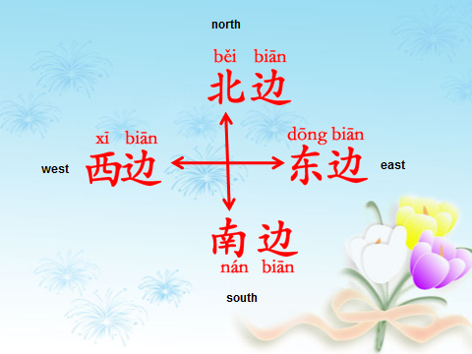

Part three: The sentence pattern for giving the directions: the use of 在1：
Place 1 | 在 | (Place2 | 的) | direction

- Beijing is in the north.

- Beijing is in the north of China.

- Shanghai is in the east of China.

- Hong Kong is in the south of China.

- The library is next to the cinema.

- The park is behind my house.

- The post office is in front of the bank.

- The train station is on the right of the shop.

- My friend’s house is next to my house.

- How can we go to the train station from home?

- We go to the train station from here by taxi.

Part four: Please ask and answer the questions in Chinese after you know the facts.
- Where is China?

- Where is the capital of China? Beijing or Shanghai?

- Where are the two main rivers in China? What are their names?

Part five: the word orders in the Chinese sentence
Who | When | Where | How | Do | What
Subject | Time expressions | 在+ place | By transport | Verb | object
我 | 每天 | 在运动中心 |  | 打 | 网球。
e.g.1． I play tennis in the sports center every day.
我和姐姐  喜欢 | 星期天 | 在商店 |  | 买 | 东西。
我喜欢 和姐姐 | 星期天 | 在商店 |  | 买 | 东西。
e.g. 2. My elder sister and I like doing shopping in the shop on Sunday.
Can you identify the difference between the sentence above and below?
I like doing shopping with my elder sister in the shop on Sunday.
Exercises
- My younger brother likes studying in the library on Saturday.

- His friend likes watching films with him in the cinema in the evening.

- We want to meet in the museum at 11am on Friday.

Challenge: what is the sentence structure when using “to go”?

_________________________________________________________________
- I like to go to my friend’s house with Amy by bus at the weekend.

- He often goes to Spain to ski with my family by plane in winter.

- They like going to the sport center to play tennis on foot on Monday.

