Part one: New words. Write down the characters with pinyin and meaning in English.
pinyin | Characters: you must write the characters in the correct orders. |  |  |  |  |  |  |  | English Meaning
 | 超 | 市
 | 买
 | 苹 | 果
 | 橙 | 子
 | 香 | 蕉
 | 葡 | 萄
 | 西 | 红 | 柿
 | 青 | 菜
 | 西 | 瓜
 | 白 | 菜
 | 元
 | 块 | 园
 | 角
 | 毛
 | 分
 | 斤
 | 公 | 斤
 | 钱
 | 多 | 少 | 钱
 | 请
 | 还
 | 太
 | 贵

Part two: How to read large numbers in Chinese.
Wàn qiān bǎi
Zero: líng零/O
Note: you need to read the zero when it is in between other numbers; if there are more than two zeros, you only need to read it once; you don't need to read it when the zero is in the end.
万 千 百 十 个
1 2, 3 4 5 ________________________
4, 9 7 6_________________________
1 6 8 ________________________
3 0 6 ________________________
7 7 0 ________________________
2 4 _______________________
3 8, 0 0 5 _______________________
6, 0 5 0 _______________________
- Challenge:
200 _______________ 268 _____________ 2,000______________ 2,094 ___________________
20,000 __________________________ 23,081 ________________________________________
Part three: Chinese currency
- To know Chinese currency terms:
Informal Formal
Yuán jiǎo fēn
元 角 分
- 3 5
一元三角五分

Kuài yuán
块 元
Máo jiǎo
毛 角
Fēn fēn
分 分
The Chinese currency sign and try to read the following prices:
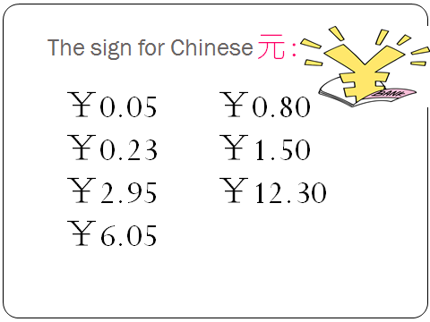

Part four: unit of weight: jīn /gōng jīn 斤/公斤
1 斤= ½ 公斤(kg)
The official unit of weight is 公斤（KG）. However, 斤 is most commonly used in dealing with small quantities of goods, especially in shops. As 斤 itself is a unit of weight, measure words are not needed in between a number and 斤. The question words are 几or 多少：几is for small amount and 多少is for large amount. Eg:
Nǐ yào jǐ jīn píngguǒ?
——你要几斤苹果? How many half a kilo apples do you want?
Wǒ yào liǎng jīn píngguǒ.
——我要两斤苹果。 I want 1 kilo.
Exercise: Make up a dialogue including: what you want to buy and how many of them you want to buy and ask and answer the price
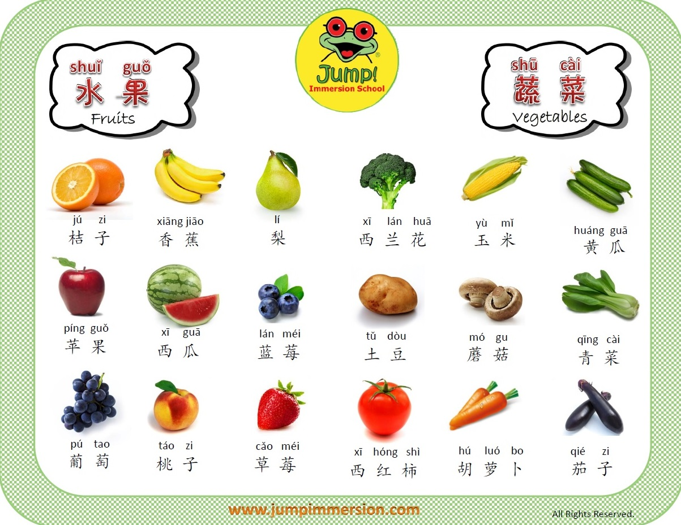
A: ___________________________________________________________________
B:

A:
B: ___________________________________________________________________

