Part one: New words. Write down the characters with pinyin and meaning in English.
pinyin | Characters: you must write the characters in the correct orders. |  |  |  |  |  |  |  | English Meaning
 | 颜 | 色
 | 黑 | 色
 | 白 | 色
 | 红 | 色
 | 绿 | 色
 | 蓝 | 色
 | 黄 | 色
 | 衣 | 服
 | 上 | 衣
 | 大 | 衣
 | 衬 | 衣
 | 裙 | 子
 | 裤 | 子
 | 袜 | 子
 | 鞋
 | 运 | 动 | 鞋
 | 旗 | 袍
 | 穿
 | 喜 | 欢
 | 条
 | 件
Part two: colors
Red | Orange | Yellow | Green | Blue | Purple
红色 | 橙色 | 黄色 | 绿色 | 蓝色 | 紫色
Hóngsè | chéngsè | huángsè | lǜsè | lán sè | zǐsè
Black | White | Brown | Grey | Color | Light/dark colors
黑色 | 白色 | 棕色 | 灰色 | 颜色 | 浅/深
hēisè | báisè | Zōngsè | huīsè | yánsè | qiǎn shēn
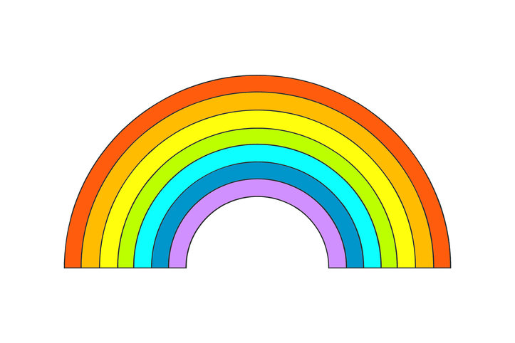
- Can you write the colors in order from inside the rainbow?

- Say the colors of the different flags: 国旗Guóqí
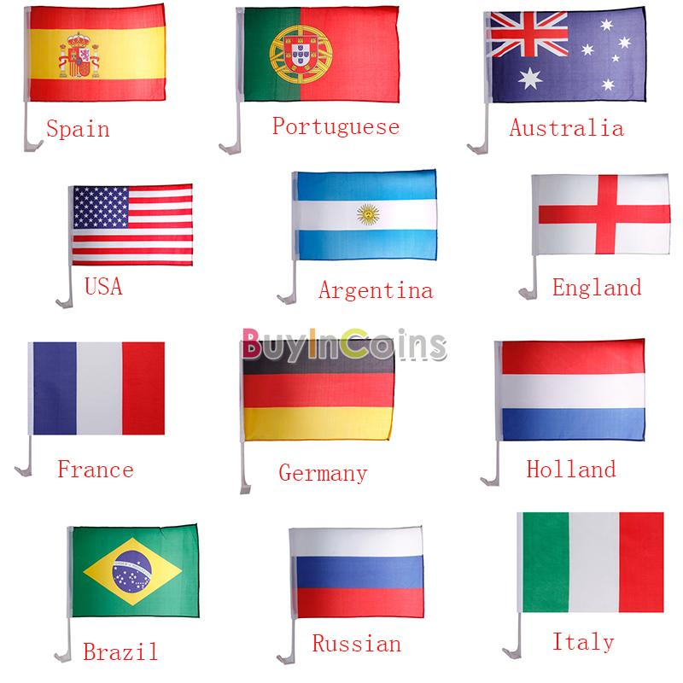
1)___________________ 2)__________________ 3)_____________________

4)___________________ 5)___________________ 6)_____________________

7)___________________ 8)___________________ 9)_____________________

10)__________________ 11)__________________ 12)____________________
Part three: how to use the colors to describe things---word order and 的
Color + de + noun-----eg. Heise de wazi, lantian—blue sky( lanse de tiankong)
Black socks______________ purple book______________ red shirt_____________

brown trousers ___________ white skirt_____________ blue shoes_____________

green coat ______________ yellow jacket______________ blue sky____________

Part four: clothing ---- independent learning words
Yīfu 衣服
Màozi
帽子 hat
Wéijīn
围巾 scarf
Shǒutào
手套 gloves
Lǐngdài
领带 tie
Chuān Dài
Yīfu kùzi
衣服 clothes 裤子 trousers
Xīfú duǎnkù
西服suit 短裤 shorts
Tàozhuāng niúzǎikù
套装 woman’s suit 牛仔裤 jeans
Chènshān cháng qún
衬衫 shirt 长裙 long skirt
Hànshān duǎn qún
汗衫 T-shirt 短裙 short skirt
Xié
鞋 shoes
Yùndòngxié运动鞋 sports shoes
Píxié皮鞋 leather shoes
Gāogēnxié高跟鞋 high heel shoes
Píng gēn xié平跟鞋 flat heel shoes
Liángxié 凉鞋 sandals
Tuōxié 拖鞋 slippers

穿 戴
To wear to wear
(accessories)

Dài
带 to carry

verb to bring 带来
to take 带走/带去

belt/girdle Yāodài腰带

noun ribbon dài zi 带子
area dìdài地带
Measure words for clothing
件Jiàn：shirt
条tiáo: trousers/skirt/scarf
双shuāng:shoes
副fù:gloves

Part four: Reading comprehension:
Try to read the characters first and see how many of them you can recognize.
我昨天和我的好朋友去了商店买东西。我买了一条蓝色的裙子， 一双黑色的高跟鞋，和一个绿色的腰带。我的朋友买了一件白色的衬衫，一条蓝色的牛仔裤和一条红色的领带。 因为天气很冷， 所以我还买了一个灰色的帽子，一条橙色的围巾和一副黄色的手套。我们下午在咖啡馆喝了点儿东西， 我要了一杯咖啡， 我朋友要了一杯绿茶。我们都很高兴。
Wǒ zuótiān hé wǒ de hǎo péngyǒu qùle shāngdiàn mǎi dōngxi. Wǒ mǎile yītiáo lán sè de qúnzi, yīshuāng hēisè de gāogēnxié, hé yīgè lǜsè de yāodài. Wǒ de péngyǒu mǎile yī jiàn báisè de chènshān, yītiáo lán sè de niúzǎikù hé yītiáo hóngsè de lǐngdài. Yīn wéi tiānqì hěn lěng, suǒyǐ wǒ hái mǎile yīgè huīsè de màozi, yītiáo chénsè de wéijīn hé yī fù huángsè de shǒutào. Wǒmen xiàwǔ zài kāfēi guǎn kěle diǎn er dōngxi, wǒ yàole yībēi kāfēi, wǒ péngyǒu yàole yībēi lǜchá. Wǒmen dōu hěn gāoxìng.
Answer the questions in English:
- Where did I go yesterday?

- Who did I go there with?

- What did I buy?

- What did my friend buy?

- Why did I buy the hat?

- What did we drink?

