Chinese sayings
Full list of the 25 Chinese idioms /Cheng Yu
No. | Cheng yu | Pin yin | Literally | explanation
1 | 画蛇添足 p184 | huàshétiānzú | Draw a snake and add feet to it | Spoil the show by doing something quite superfluous | 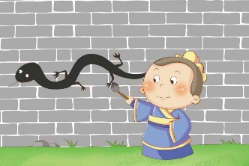
2 | 坐井观天 p608 | zuòjǐngguāntiān | Looking at the sky from the bottom of a well | To have a narrow view; to have a restricted outlook | 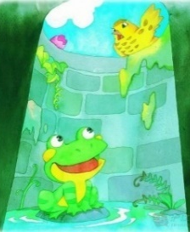  2016
3 | 拔苗助长 p7 | bámiáozhùzhǎng | to pull the shoots to help them grow | to spoil something with a desire for quick success. | 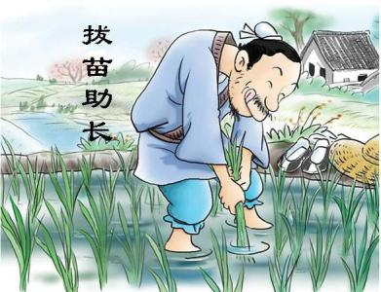  2012
4 | 对牛弹琴 p112 | duì niú tán qín | play the lute to a cow | Address the wrong audience; talk over someone’s head | 2017 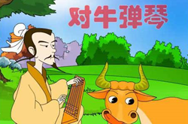
5 | 纸上谈兵 p584 | zhǐshàngtánbīng | Discussing military tactics on paper | to have unrealistic ideas; talks armchair strategies | 2016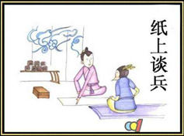
6 | 自相矛盾 p603 | zì xiāng máodùn | The (best) spear against the (best) shield. | To say or do something to contradict oneself; Self-contradictory. | 2015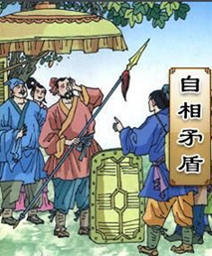
7 | 入乡随俗 | rùxiāngsuísú | When you enter a village, follow the local customs | When in Rome, do as the Romans do | 
8 | 覆水难收 p137 | fùshuǐnánshōu | Water thrown out/poured out is hard to put back into the container | Things done cannot be undone. | 2016
9 | 唇亡齿寒 | chúnwángchǐhán | The teeth will feel cold if lips are gone. | This expression describes closely related interests. The first cannot survive without the second. | 2013 2017
10 | 如鱼得水 p380 | rúyúdéshuǐ | like a fish back in water | Be in congenial company or do congenial work | 2018 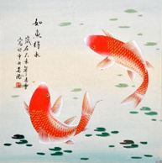
11 | 青出于蓝 p363 | qīngchūyúlán | Indigo came out of blue, but is prettier than blue | the pupil often surpasses the master | 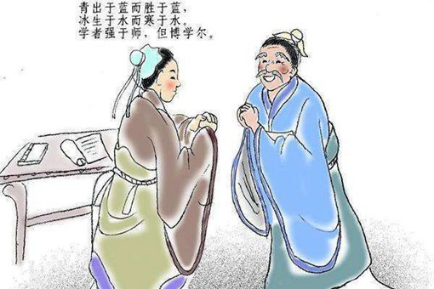
12 | 亡羊补牢 | wángyángbǔláo | to mend the pen after sheep are lost | better late than never | 2018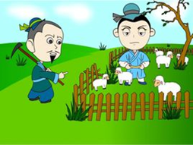
13 | 饮水思源 p536 | yǐnshuǐsīyuán | Do not forget about the source of the water you are drinking | One should keep in mind the source of one's joy while in happiness | 2016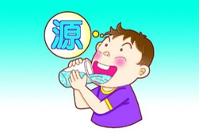
14 | 打草惊蛇 p84 | dǎcǎojīngshé | beat the grass to scare the snake | Act rashly and alert the enemy | 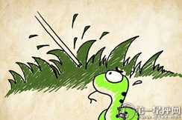
15 | 四海为家 p430 | sìhǎi wéi jiā | to regard the four corners of the world all as home | Make one’s home no matter where one lives and works | 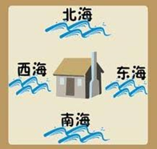
16 | 骑虎难下 | qí hǔ nán xià | Who rides on a tiger can never dismount | Unable to back down or quit; unable to extricate oneself from a difficult situation | 
17 | 塞翁失马 | sài wēng shī mǎ | the old frontiersman, Saiweng, losing one of his horses | A blessing in disguise; every cloud has a silver lining. | 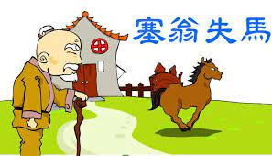
18 | 闻鸡起舞 | wén jī qǐ wǔ | Rise up upon hearing the crow of a rooster and practise with the sword | Diligent and self-disciplined | 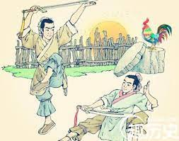
19 | 愚公移山 | yú ɡōnɡ yí shān | Yu Gong (the foolish old man in a Chinese parable) who removes the mountains | Where there is a will, there is a way; do seemingly impossible things with dogged perseverance and succeed eventually | 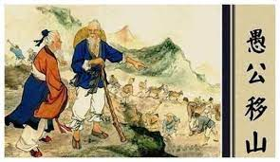
20 | 过目不忘 | guò mù bù wàng | Remember after one reading | A photographic memory; a very retentive memory | 
21 | 水落石出 | shuǐ luò shí chū | When the water subsides, the rocks emerge | Eventually truth will prevail | 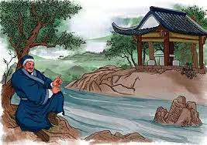
22 | 草船借箭 | cǎo chuán jiè jiàn | using thatched boats to borrow arrows (idiom from Sanguo Yanyi 三国演义) | To use others’ manpower and resources for one’s own ends | 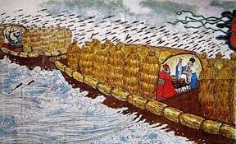
23 | 步步为营 | bù bù wéi yíng | Advance gradually and dig in at every step | Act cautiously | 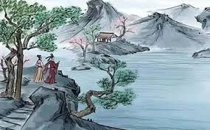
24 | 草木皆兵 | cǎo mù jiē bīng | Every bush and tree looks like an enemy solider | Be in a state of extreme suspicion and fear | 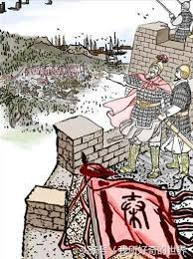
25 | 鸟语花香 | niǎo yǔ huā xiāng | Birds sing and flowers give forth fragrance | As on a fine spring day | 

