Edexcel GCSE Chinese Chapter6 Holidays
----6 Making travel arrangements---talking about sequences of activities
第一部分：词语学习
Write down the characters and Pinyin in the boxes. Write the characters five times or more until you can write them from memory. When learning the new words, copy the characters, and write pinyin and English. Use Green book to do more handwriting practice.
English | Pinyin | Characters
 |  | 旅行安排
 |  | 旅行袋
 |  | 飞机票
 |  | 订机票
 |  | 护照
 |  | 身份证
 |  | 手机
 |  | 照相机
 |  | 钱包
 |  | 地图
 |  | 帮忙
 |  | 司机
 |  | 丢了
 |  | 站台
 |  | A number+ 站台
 |  | 出发
 |  | 到达
 |  | 接/接站/接+ people
 |  | 车次
 |  | 目的地
 |  | 登机口
 |  | 介意
 |  | 游学
 |  | 联系
 |  | 行程
 |  | 行程安排

第二部分：GCSE Chinese Reading practice
- A complaint
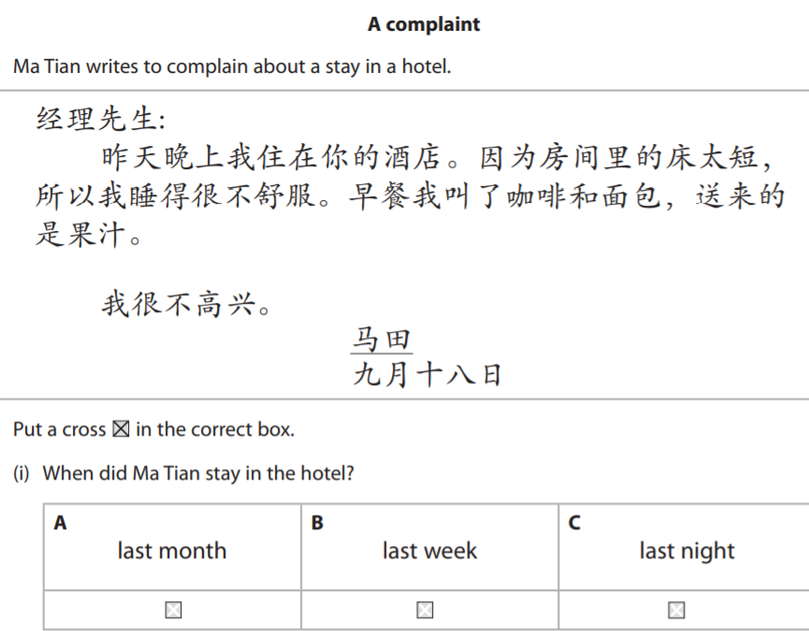
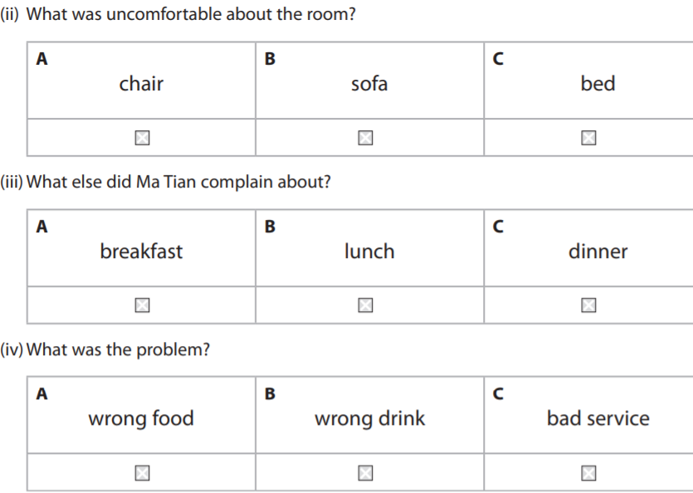

- A visitor
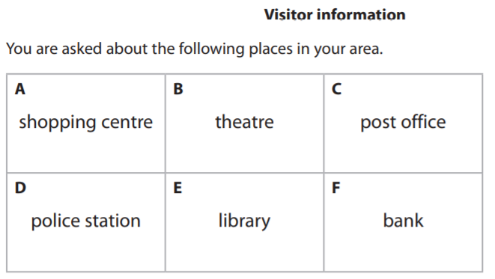
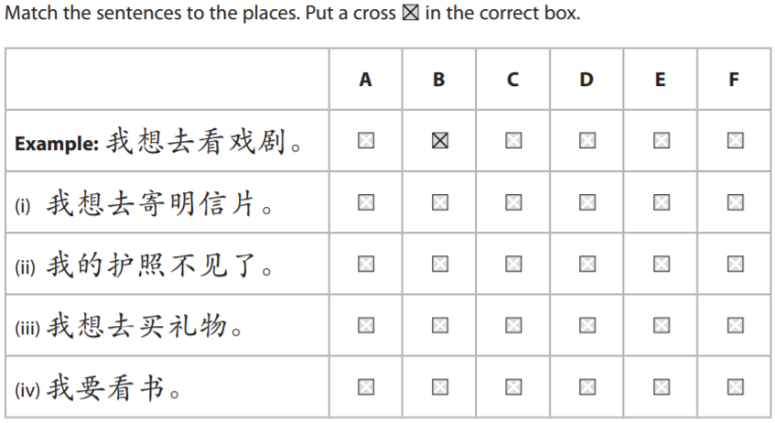
- A house
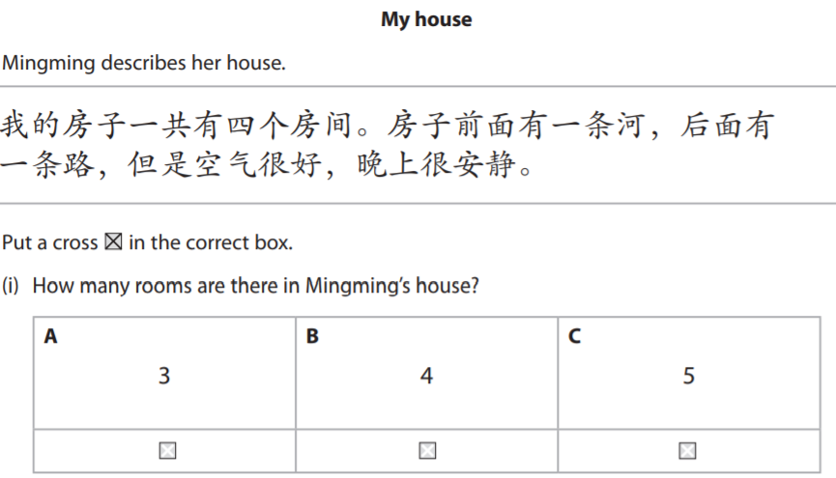
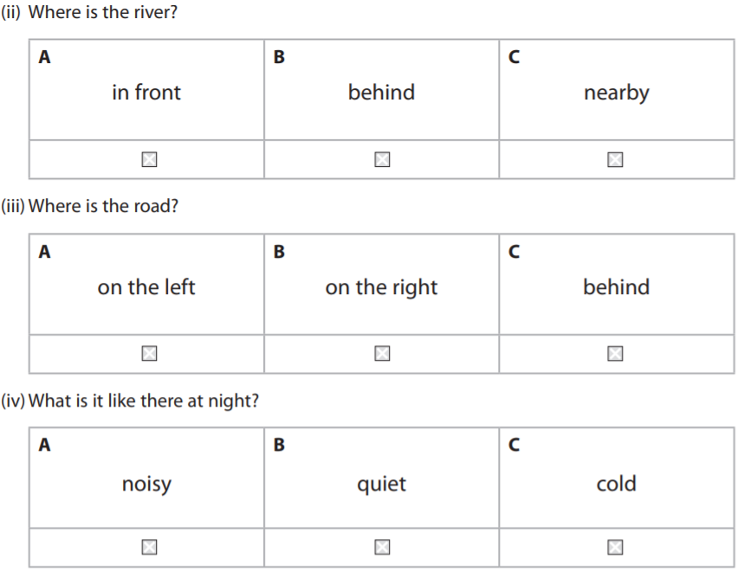

第三部分：GCSE Chinese speaking practice
You are in the lost property office and report that you have lost a travel bag and tell the officer what are in the bag and describe some items with specific feature.

