Edexcel GCSE Chinese Chapter6 Holidays ---- Revising weather and transport
第一部分：词语复习
Write down the characters and Pinyin in the boxes. Write the characters five times or more until you can write them from memory. When learning the new words, copy the characters, and write pinyin and English. Use Green book to do more handwriting practice.
English | Pinyin | Characters
Have a holiday

Weather

Weather forecast

Sunny

Windy

Rainy

Snowy

Foggy

Hot

Warm

Cold

Cool

Change into

In addition

Transport

To take/catch a vehicle
Train

Bus

Plane

Subway

To ride

Bike/ bicycle

To drive/
By car

To walk/
On foot
Usually

Normally

Often

 |  | 停
 |  | 啊
 |  | 太糟糕了
 |  | 这两天
 |  | 最好
 |  | 雨伞
 |  | 带
 |  | 安全
第二部分：语法解释和练习
- The use of 最好：1) 最好+ Verb-----You’d better……. when giving advice to someone.
2) 最好的 + noun---- the best……
e.g.1) 今天很热，你最好多喝水。It is hot today, and you’d better drink more water.
2)这是最好的中文书。This is the best Chinese book.
Exercise:
- Beijing is very hot in Summer. When you have a holiday there in July, you’d better bring some short sleeves T-shirt. (短袖衬衣)

2） To tell your friends, they had better not walk to school, as it will be too windy tomorrow morning.

- How to use “be likely to and possibly”
Translate the following sentences to English.
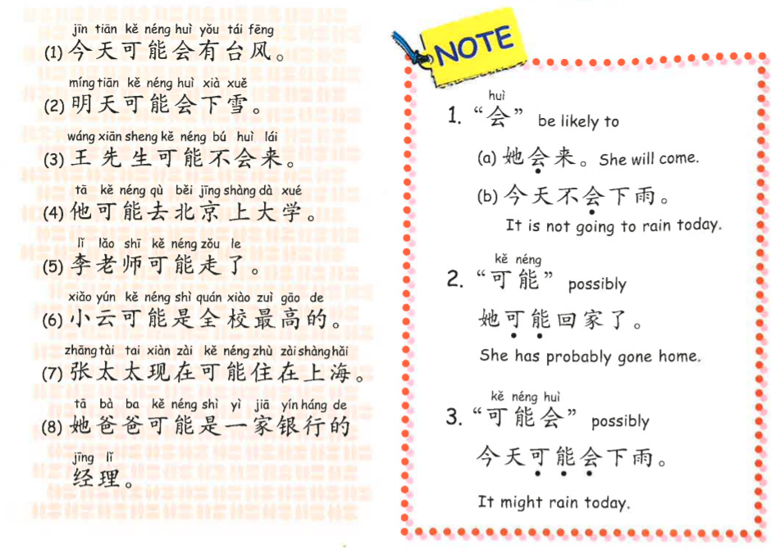

- ___________________________________________________________________________

- ___________________________________________________________________________

- ___________________________________________________________________________

- ___________________________________________________________________________

- ___________________________________________________________________________

- ___________________________________________________________________________

- ___________________________________________________________________________

- ___________________________________________________________________________
第三部分：词语练习
Match the words with the pictures and guess the meaning if you haven’t learned the words
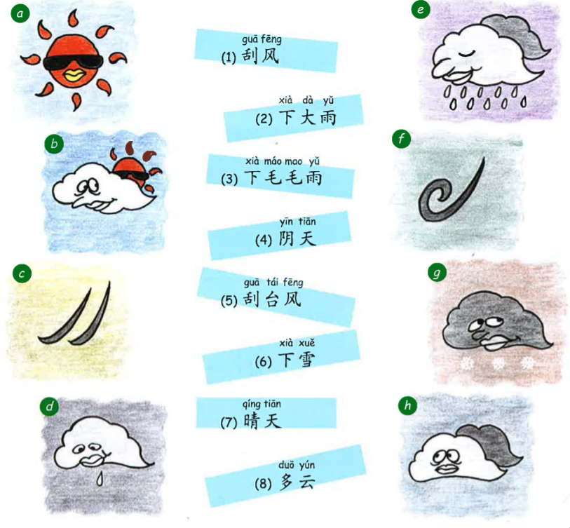

(1)______(2)_______(3)______(4)_______(5)_______(6)_____(7)________(8)__________

第四部分：Self-learning material --- more transports that you are interested in.
