My Story of Being an ABC (American-Born Chinese)
MAY 4, 2019 Katherine Chang
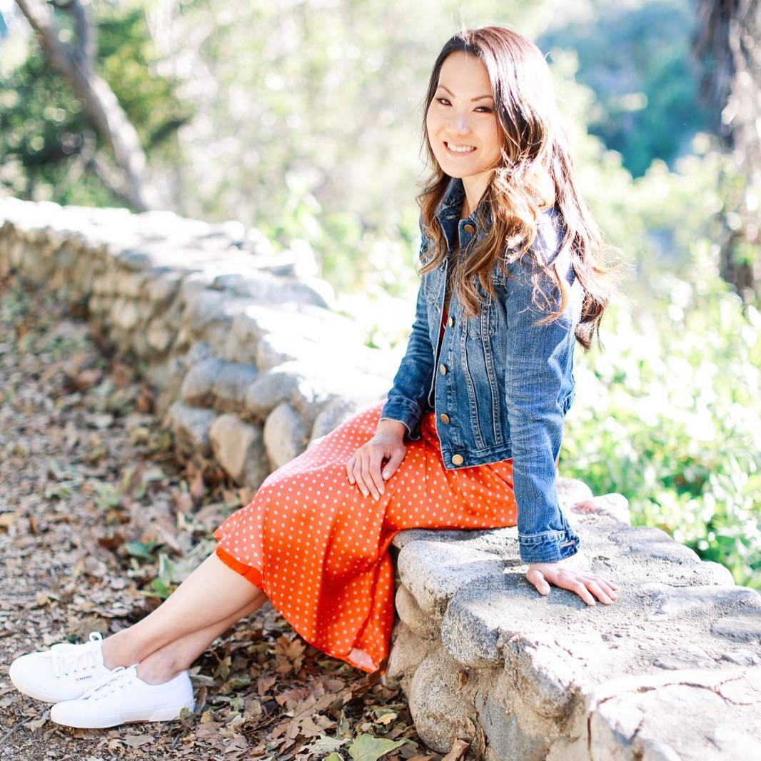
Every late January or early February — the time of year when hundreds of millions of American families gather around the TV with chips and dip and hot wings to tune into the ultimate showdown on the gridiron (ICYMI, I’m talking about the Super Bowl) — my extended family gathers around a large round table, complete with a Lazy Susan rotating a feast of foods, each promising to bring special meaning in the new year. Think: a whole fish symbolizing abundance; chicken, good luck; dumplings, wealth; noodles, longevity; and sticky rice cake, prosperity. Then there’s the clattering of tiles in an intense game of Mahjong played by my parents and aunt and uncle, and chattering of Chinglish — Chinese Mandarin mixed in with English — between my cousins, sister, our Gonggong and Popo (aka grandpa and grandma), and me. This is the start of the Lunar New Year, or as it’s more commonly known, Chinese New Year.
The highlight of the holiday growing up was the red envelopes we’d receive every year as a gift and token of good luck, each containing a crisp bill and that I couldn’t wait to open and discover which president’s face I’d find. (I’ll admit, it still ranks pretty high up there.) But at the center of Chinese New Year is hands down family, so much so that it’s regarded as the most important holiday in China. Hundreds of millions of people travel home to reunite with their families for Chinese New Year’s Eve dinner, making it the largest human migration in the world — something I equate to the half-mile security line of impatient Americans that is the Christmas Eve rush at LAX.
My parents immigrated to the U.S. in their teenage years, leaving their families behind to pursue the American dream. They both were Huskies at Northeastern University where my dad first laid eyes on my mom in a Chinese class she was teaching for fun. Let’s just say he was there to learn more about the teacher than the subject, fell hard for her, was persistent, and the rest, as they say, is history.
Because they were thousands of miles away from their families, they found comfort in being around other Chinese students, sharing in familiar customs and values (not to mention language), while also starting new traditions of their own. With Chinese New Year falling during the school year, they couldn’t travel home to celebrate with their families, so they would get together with their classmates over a potluck of fish, chicken, dumplings, and noodles (sound familiar?).
Hundreds of millions of people travel home to reunite with their families for Chinese New Year’s Eve dinner, making it the largest human migration in the world. 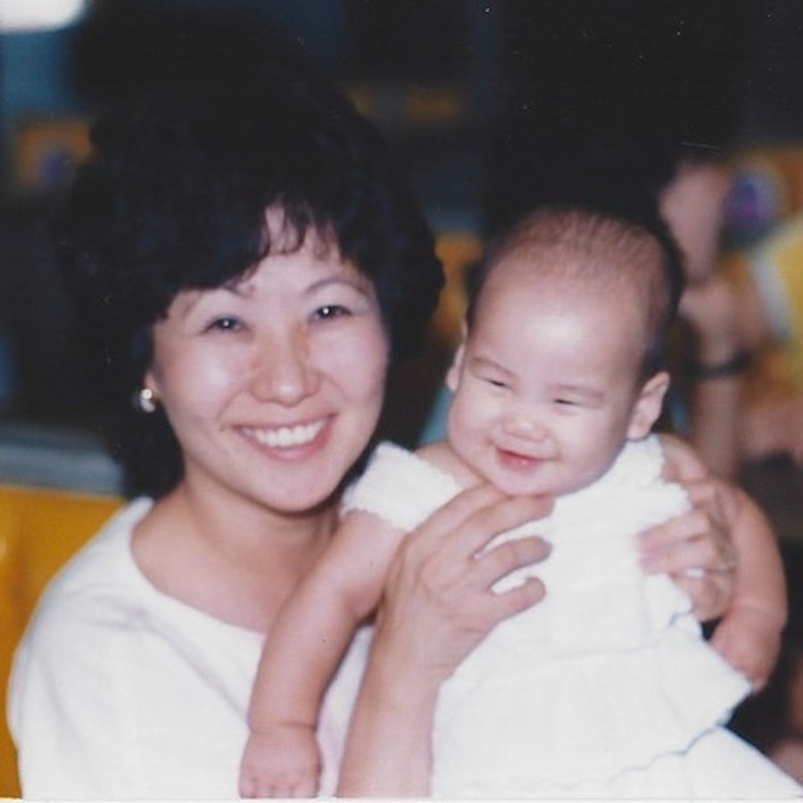

Much in the same way they combined old and new traditions in college, my parents passed down Chinese customs blended with American practices to my sister and me. At an early age, they instilled the importance of family loyalty, modesty, and humility, as well as self-confidence. We ate every grain of rice on our plates so that our future husbands wouldn’t have a lot of pimples (one of many Chinese superstitions our mom scared us with to obey her), yet we shared about our long work days and how we did on our history tests in English around the dinner table.
At an early age, they instilled the importance of family loyalty, modesty, and humility, as well as self-confidence.
As far as I know, my sister and I grew up much like our American friends. We watched the local firework display on the Fourth of July, gave thanks with family over turkey, and trimmed the Christmas tree every year. The only difference? Interspersed between the turkey, mashed potatoes, and green bean casserole, you’d find a Chinese version of stuffing, eggrolls, and noodles.
While my American friends enjoyed Saturday morning cartoons over a bowl of cereal, I was in Chinese school learning how to read, write, and speak Mandarin. The last period of the day was reserved for extracurricular activities, like origami (paper airplanes were for amateurs. I’m talking paper jumping frogs, shirts made from a dollar bill, you name it.), Chinese calligraphy (thanks to that class I will never forget how to write my Chinese name), and Chinese folk dancing (picture ornate costumes with equally ostentatious headpieces that you may see in old Chinese movies and that were as uncomfortable as they looked). Chinese folk dancing was instantly my favorite, not surprisingly as I already had a love for dance from taking jazz, tap, and ballet. It was just one of the many ways I linked my Chinese and American identities.
I had two different sets of friends — one from American school and the other from Chinese school — but no matter who I was with, I felt like I belonged. I was never ashamed that I looked different than my American friends, nor did I ever try to be someone I wasn’t. But I do remember being envious of them for their big eyes and double eyelids (both of which many Asians aren’t born with and the latter something so envied that they’ll go under the knife for). I would feel offended when kids would pull the corners of their eyes to “look Chinese,” refer to every Asian man they had seen on TV as “that Chinese guy” even if he wasn’t, or fall prey to any of your run-of-the-mill Asian stereotypes.
I was never ashamed that I looked different than my American friends, nor did I ever try to be someone I wasn’t. But I do remember being envious of them for their big eyes and double eyelids.
For one, not all Asians are bad drivers (I’d like to think I don’t perpetuate that one). I wasn’t a math whiz and I didn’t have aspirations to become a doctor, lawyer, or engineer, either. I will say part of me felt guilty for not fitting into those generalizations, as if perhaps I wasn’t representing my ethnicity in a way that others felt I should be or that I might be disappointing my parents. But, unlike many Asian kids I knew, I don’t have Tiger parents (another stereotype) who were all about strict rules, tough love, and discipline (not to say there’s anything wrong with that approach).
Don’t get me wrong — my parents had expectations for us, but I never felt academic pressure from anyone other than myself or coerced into anything I didn’t want to do (OK, maybe Chinese school and piano were exceptions).
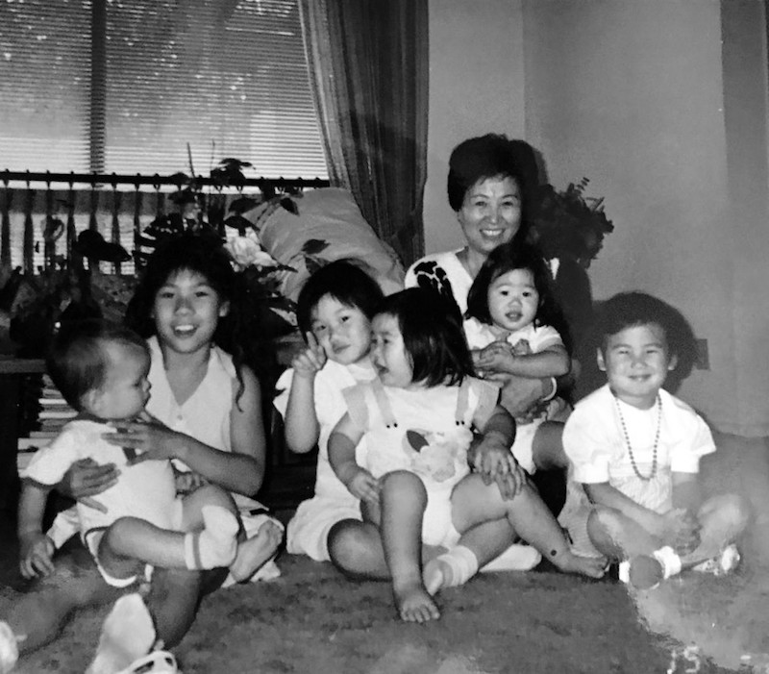
The neighborhood where I grew up is predominantly white, so it wasn’t until I went to UCLA (aka University of Caucasians Lost Among Asians) that I realized how much I identified with and appreciated my culture. Sure, I had friends from Chinese school who I’d see on the weekends, but because I was away from home (albeit only 40 minutes) and out of my so-called bubble, being surrounded by other Asians was, in a way, liberating. Both of my freshman roommates happened to be Asian and I quickly befriended Chinese friends through an Asian American group I joined. I didn’t have to explain the weird-smelling tofu dish my mom packed for me after going home for the weekend or why I rearranged my bed and desk to face the entry door (read: a feng shui basic). We had an unspoken understanding of one another.
Fast-forward to today: I regret not appreciating Chinese school and taking it more seriously when I was in it. I can speak Mandarin fluently, but with an American accent that’s a dead giveaway that I’m an ABC (American-born Chinese) to a native Chinese person. (Although, I’ve been told my looks are the first indication — one double eyelid and all). Regardless, I now speak to my parents in Mandarin more than ever, not because I feel obligated to, but because I am proud that I can and I want to be an example to my future children.
I now speak to my parents in Mandarin more than ever, not because I feel obligated to, but because I am proud that I can and I want to be an example to my future children.
With the recent passing of my last surviving grandparent, my Popo, there will be one less family elder at next year’s Chinese New Year celebration. It has made me cherish the traditions we as a family have created together that much more and I now realize it’s up to my cousins, my sister, and me to continue them. Come next January when we welcome the Year of the Rat (which happens to be my zodiac sign), I’ll get the chance to do just that by gifting a red envelope for the first time — to my new nephew, Kellan.
(Originally from: https://theeverygirl.com/my-story-of-being-an-abc-american-born-chinese/ )

