My MEP Projects
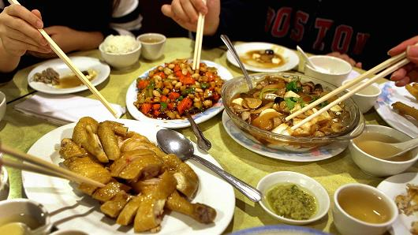

Project: Chinese cuisine, street food and restaurant food
Series: Food

Name: ____________________

Chinese food can be found in every corner of the world, but if you’ve only eaten in Chinese restaurants in the UK you may be shocked by its surprising range and variety of ingredients. Let’s find out about the major types of Chinese cuisine, get to know a vast variety of street food and we will also go to explore a Chinese restaurant.
Go for it!

- Eating Habits in China
Different countries have different eating habits. How much do you know about eating in China? Do you think the following statements are true or false? Provide your answer if you think it is false.

Check these websites to help you find the answers!
http://www.topchinatravel.com/china-guide/chinese-dining-culture.htm
https://www.chinahighlights.com/travelguide/chinese-food/dining-etiquette.htm
https://www.chinahighlights.com/travelguide/chinese-food/things-to-know-on-eating.htm

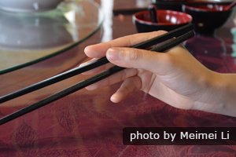
- Chinese use chopsticks to pick up food, so knives, forks and spoons cannot be found in Chinese restaurants.

True/False_________________________________

- In terms of seating, the seat facing the door is for the host. The most important guest usually sits on the host’s left, while the second most important guest sits on the host’s right.
True/False_________________________________

- Older people eat first, or if you hear an older person say "let's eat", you can start to eat.

True/False_________________________________

- Meat and vegetable dishes are served on plates or in bigger bowls, placed in the middle for everyone to share. It's not on individual plates, like in the West.

True/False_________________________________

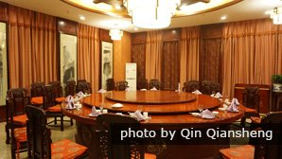
- After you have ordered, tea or a different drink and cold dishes will be served first. Soup is then served. A selection of hot dishes often made of the last dish of a meal, followed by fruit for dessert.

True/False_________________________________

- The ingredients of Chinese food are varied (frogs, chickens' feet, pigs' ears, intestines etc.) and can sometimes appear shocking to non-Chinese.
True/False_________________________________
- There are usually salt and pepper shakers, or bottles of tomato sauce on the table.
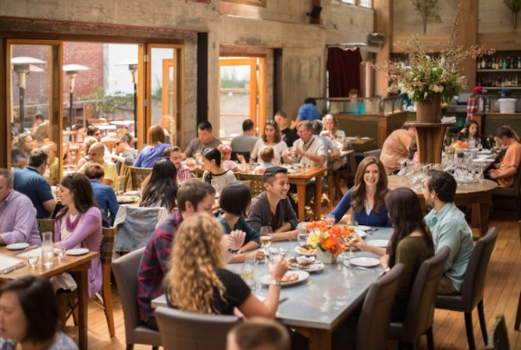
True/False_________________________________

- Chinese restaurants are places for people to socialize with friends and because of this the talking volume would be a lot louder than in restaurants in the UK.
True/False________________________________

- Tips are expected in Chinese restaurants.
True/False_________________________________

- If the Chinese friend you are eating with puts food on your plate, it's to show closeness and friendliness, not because they don't want it, or think you can't do it yourself.
True/False_________________________________
Task 1 complete

- The Major Cuisines of China
Now you’ve looked at some of the “rules” Chinese people have when eating together, it’s time to look at what types of food they might be eating! Follow the link below to watch a video introducing the major cuisines of China. Cuisine in Chinese is烹饪(pēngrèn)
https://www.youtube.com/watch?v=_pqI1ETCYnU&t=145s (7.45 minutes long)
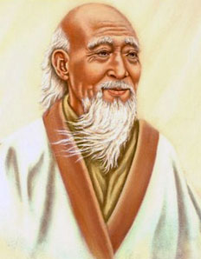
Task A:
Listen to the first minute of this video, you will hear a person called Laozi mentioned. Laozi (or Lao Tzu), was an old figure who it is said lived in the 6th century B.C. He was a great philosophy and the founder of the Chinese philosophical ‘School of the Tao’ or ‘Taoism’. Can you guess how to write his name in Chinese? Here is a clue for you: the literary translation of his name is ‘Old Master’. The first character is ‘old’ and the second character is ‘son’.
_________________________

Now listen to the rest of the video. In each section below, one type of cuisine is introduced. What is it? Listen to each section and try to find its name. For a bigger challenge, since you are now getting pretty good at Chinese, try to write down each type of cuisine in Chinese characters and pinyin. (In a Y7 project – “The Land that is China”, we talked about Chinese provinces, it can help you with the characters if you need any help.)

Video sections | Cuisine name | Province(s) | Pinyin | Chinese characters
1:00 to 2:00 | Sichuan Cuisine | Sichuan | sìchuān pēngrèn | 四川烹饪
2:00 to 3:55
3:55 to 5:20
5:20 to 6:35 |  | (four provinces)
6:35 to 7:45 |  | (three provinces)

Task B: Find and circle the regions where the cuisines are from on the map below.
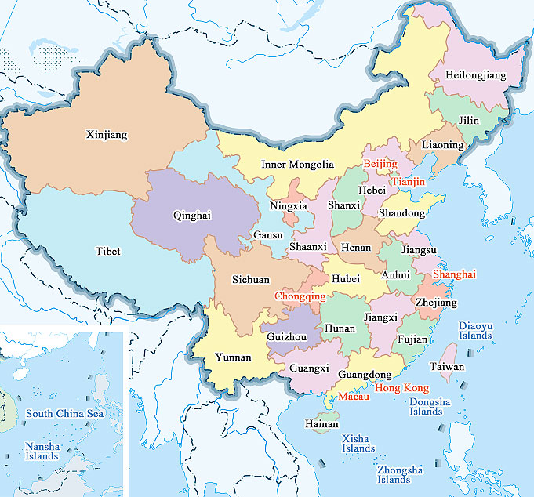

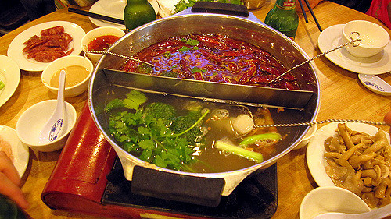

Task C: In the video, it mentions the typical taste of each cuisine- can you remember what they were? If not, watch the video again and do some matching!
- Sichuan cuisine (or 四川烹饪)
- Salty
- Rich
- Spicy
- Sweet
- Fresh

- ________________________

- ________________________

- ________________________

- ________________________

Task D: Exactly! Each type of cuisine has its own unique taste. How do you describe ‘flavour’ in Chinese? Can you put the Chinese characters below in the correct box and find out their pinyin? Use your dictionary if you need any help.
- 咸 | - 辣 | - 鲜 | - 甜 | - 浓郁

 | Pinyin | Character | Practice writing the characters
Spicy | là | B. 辣
Fresh

Salty

Sweet

Rich

Task E: Interview! You have learnt something about Chinese cuisines and their flavour. Which type of cuisine do you think you will want to try when you get to China? Read the following words by Mike Chen, the video presenter and say something about yourself.
Now, it is your turn!
“我爱吃四川菜，也爱吃山东菜和东北菜。我最爱吃四川菜，因为四川菜很辣。我不爱吃粤菜，也不太爱吃淮阳菜。”

Language tip: “最zuì” means “the most”, you can put it before a verb. For example: 我最喜欢北京means I like Beijing best.

Task 2 complete

- Insanely yummy street food in China
One thing you can’t miss in China is the opportunity to try the delicious street food - you definitely will find it an unforgettable experience! Let’s have a street food tour around China and check out the most unique Chinese street food. While watching the video, try to remember as many street food as possible!

https://www.youtube.com/watch?v=e1QThvrEMr4 (13.08 minutes long)

You must now be very hungry! To prepare for your future food tour, let’s first look at the English names of these street foods in Task A and then you need to figure out their equivalent Chinese names and pinyin in Task B. You can look for the vocab boxes to help you but you should work out the pinyin by yourself.

Task A: match the English name with the pictures

- Dumplings in sour soup 2. Century old egg
3. Chinese roast duck 4. Cheong fen
5. Hand pulled Lanzhou noodles 6. Street popcorn

7. Durian chicken hot pot

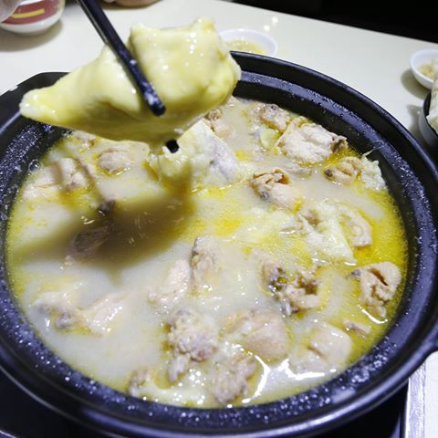

Task A: 7.Durian chicken hot pot
Task B: A.榴莲鸡肉火锅
__________liúlián jīròu huǒguō

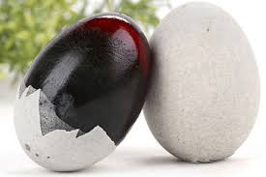  ___________________  ___________________  ___________________ | 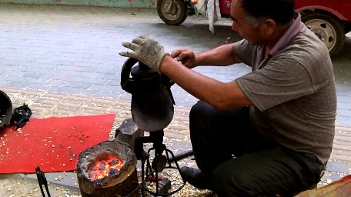  ___________________  ___________________  ___________________ | 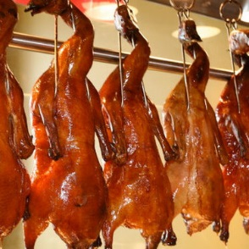  ___________________  ___________________  ___________________
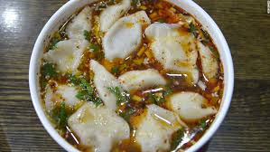  ___________________  ___________________  ___________________ | 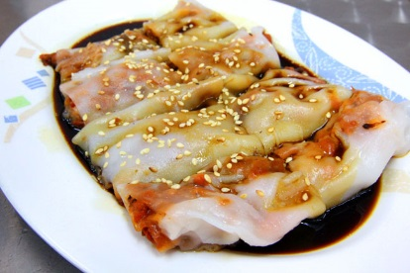  ___________________  ___________________  ___________________ | 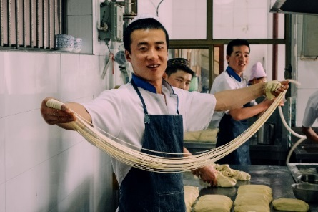  ___________________  ___________________  ___________________

Task B: Can you figure out the Chinese names of the above street food? Let’s give it a go and use the basic words that you’ve already known such as鸡肉，米，面，饺子。Then add the names in the chart above.

- 榴莲鸡肉火锅 liúlián jīròu huǒguō B. 酸汤饺子 suān tāng jiǎozi

C. 皮蛋 pídàn D.烤 鸭 kǎoyā

E. 爆米花 bào mǐhuā F. 肠 粉 cháng fěn

G. 兰州拉面 lánzhōu lāmiàn

Task C: Interview! Since you’ve got to know the Chinese street food and you’ve also understand how to express tastes in Chinese, now tell us a bit more about your preference and your understanding of the street food.
Okay, tell me what you would like to try most? 你最想吃什么？

我最想吃 _________________
你觉得什么很甜？
我觉得_________________很甜。
你觉得什么很酸？
我觉得_________________很酸。
你觉得什么很辣？
我觉得_________________很辣。
Is there something you definitely DON’T want to try? How would you say that?

Task 3 complete

- Ordering food in a Chinese restaurant
However delicious Chinese food is, reading a Chinese menu is always a challenge to non-Chinese people, because the names of the dishes are always very long and involve description of the dish, the key ingredients and the cooking methods. Then how to order food in China? Don’t worry, a good thing is that quite often there are pictures of the dishes next to their names on the menu to help you with your decision. All you need to do is to read the menu to look for the key words you know, for example: 鸡，鸭，鱼，面条. And then point at the pictures when you order food.

Task A: Read the restaurant menu below. Do you fancy some of the dishes? Tick on the picture of the dish if you would like to try it. Use the glossary to help you.

蚌 bàng mussel
鸡 jī chicken
鹅 é goose
鸭 yā duck
猪手 zhūshǒu pig trotter
吞拿鱼 tūn ná yú tuna fish
鲈鱼 lúyú bass
生鱼 shēng yú raw fish
桂鱼 guì yú mandarin fish
鱼翅 yúchì shark fins
参 shēn sea cucumber
生蚝 shēngháo oysters
鳝 shàn eel
大肠 dàcháng pig intestine
叉烧 chāshāo sweet roast pork
凉粉 liángfěn bean jellies

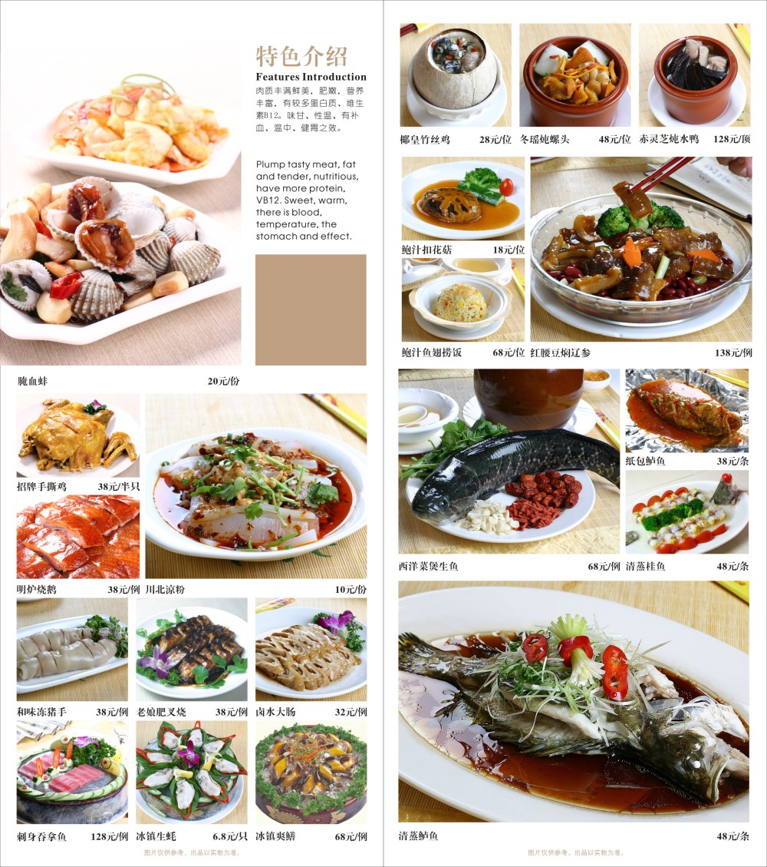

List some dishes that you want to try.

(in Chinese characters) 清蒸鲈鱼——(What do you think this is in English?) steamed bass

(in Chinese characters) ____________ (What do you think this is in English?) _________________

(in Chinese characters) ____________ (What do you think this is in English?) __________________

Task B: Now you know the menu, let’s go to the restaurant to order some food. In the restaurant, the waiters and waitresses are called 服务员 (fúwùyuán). If you need any help, you can just call “服务员” and they will come to help you. Fill in the blanks below and order whatever dish on the menu you would like to try.

服务员：您好，欢迎光临huānyíng guānglín。
服务员：请坐这里。
你：_____________
服务员：这是我们的菜单càidān。
你：_____________

你：我们可以点菜了吗？wǒmen kěyǐ diǎn càile ma. Can we order now?
服务员：当然可以，您想吃什么？
你：(I would like to have ---)___________
服务员：好的。

你：(The food is very delicious. Thank you. May I have a glass of water, please. )_
你：(Bill please. )_____________
服务员：这是您的账单zhàngdān。

服务员：谢谢光临,再见。
你：________________________

Task C: Acting time! Imagine you are in a Chinese restaurant to order food and you have a conversation with the waiter or waitress. Find a partner to act the scene out and video yourselves. If you like, share the video with your teacher or the other classmates. For extra practice, can you add subtitles in Chinese?

Task 4 complete

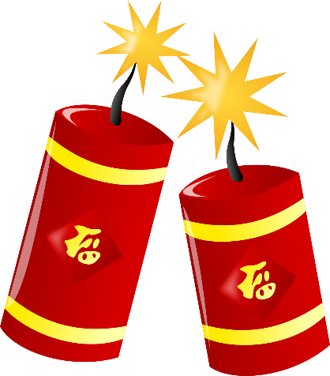
太棒了！

Well done!

Your Achievements
Congratulations on completing 1 MEP Project!

- You now have a clearer understanding about eating manners in China.
- You have known something about Chinese cuisine and street food.
- You’ve had a go of ordering food in a restaurant.
- You might also have built up an appetite for travel and Chinese food!

If your teacher signs you off,
you will collect 1 Badge!

