My MEP Projects

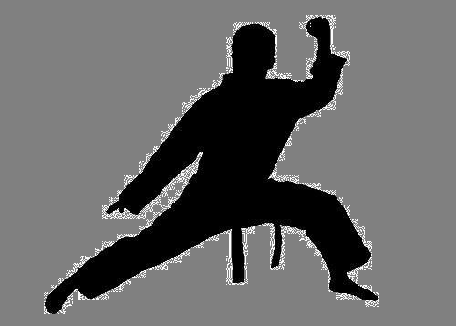
Project: Martial Arts – Kung Fu
Series: Culture

Name: ____________________

Welcome, Warrior!

Have you ever watched Kung Fu Panda or Karate Kid? Have you heard of the actor Jackie Chan? This is the Project to learn more about the fascinating and ancient skills of Chinese martial arts.

Please do not try any moves at home or school. Only try anything with a kung fu professional in a class as otherwise you could hurt yourself or others.

Go for it!

- Wow!
Watch this video to find out what we’re going to be learning about in this Project:

https://www.youtube.com/watch?v=3FDL4ZYEfcw

Now, answer a few questions about the video:
- Did you know that kung fu schools like this existed? _______________________________________
- Would you like to study there? _______________________________________
- Give a reason for your previous answer. _______________________________________
- Do you think life looks hard at the school? _______________________________________

Task 1 complete

- Chinese, Japanese, Korean or Brazilian?
Look at each name of martial art below and put a C next to it if you think it’s from China, K if you think it’s Korean and J if you think it’s Japanese. There is also one from Brazil, so put a B next to whichever you think it is.
Karate
Kung fu
Taekwondo
Tai chi
Jujutsu
Capoeira

Task 2 complete

- The term for ‘martial arts’

Chinese wǔ shù (= martial arts) are stunning. Let’s just take a minute to appreciate the two characters for wǔ shù.

武术

Look up each character individually and write down what it means in English. Then practice writing it out in the boxes provided.

English
武
术

Task 3 complete

- Kung fu – hard work from a young age!
You might think the word for kung fu (功夫gōng fu) just refers to 武术. But it is a lot broader than that. Look up the word and write down what else it can mean.

Answer: ______________________________________________________________________________

In fact, 功夫can refer to many other things that somebody is highly skilled in, such as playing a musical instrument or making tea.
It can also describe something that was made with a lot of effort and skill such as a piece of writing.
Translate this example, looking up any words you might be sure of:
他 的 书 法 很 有 功 夫。
Tā de shū fǎ hěn yǒu gōng fu.

Answer: ________________________________________

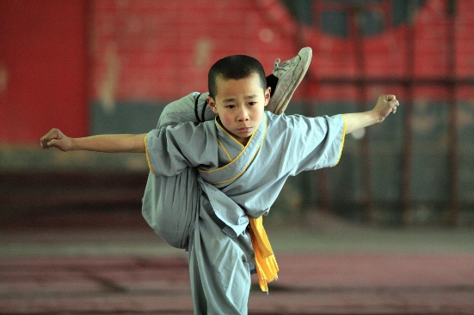
Very often, however, it does refer to the martial art. 功夫 (kung fu) has developed over many centuries and there are thousands of different types. One of the most famous is Shaolin 功夫, which we are going to explore in this Project.
Shaolin Temple (少林寺shào lín sì) is where this type of 功夫originated. Children as young as six leave home to take the tough training at the temple. Anyone can go – even you!

Click the following link and scroll to the bottom of the web page to see children from various countries who have studied at 少林寺:
https://shaolintemple.com/our-students

Listen to this girl talking about joining a 功夫school early on in her life (just watch between 07.17 and 08.24 for now): https://www.youtube.com/watch?v=SaFMkcsYJFw

小蓝Xiǎo Lán – the Kung Fu Student!
Now it’s time to meet a teenage 功夫 artist called小蓝Xiǎo Lán and read about his life, learning 功夫.
Look through the glossary of words, then read through each paragraph of the text to find out about this amazing young fighter’s life. Answer the questions in English.
Note: You can always look back at the glossary. All underlined words in the text have been given their English meaning in this glossary, so for others you may need to check the dictionary.
Vocabulary for paragraph 1

厉害lì hài = awesome
年轻人 nián qīng rén = young person
功夫gōng fu = kung fu
从小cóng xiǎo = from young (since he was little)
少林寺shào lín sì = Shaolin Temple
一大早 yí dà zǎo = at the crack of dawn, first thing in the morning
做早操 zuò zǎo cāo = do morning exercise
继续jì xù = to continue
练liàn = to practise
一直到yì zhí dào = right up until, all the way until
健康jiàn kāng = healthy

小蓝是一个很厉害的年轻人，因为他会功夫！他从小住在少林寺。
Xiǎo lán shì yí gè hěn lì hài de nián qīng rén, yīn wèi tā huì gōng fu! Tā cóng xiǎo zhù zài shào lín sì.

小蓝每天一大早起床做早操，然后他吃早饭，再去继续练
Xiǎo lán měi tiān yī dà zǎo qǐ chuáng zuò zǎo cāo, rán hòu tā chī zǎo fàn, zài qù jì xù liàn

功夫一直 到 晚上。
gōng fu yì zhí dào wǎn shàng.

因为小蓝每天做这么多运动，所以他是一个很健康的人。
Yīn wèi xiǎo lán měi tiān zuò zhè me duō yùn dòng, suǒ yǐ tā shì yí gè hěn jiàn kāng de rén.

Questions on paragraph 1
- Where has Xiao Lan been living?
- What does he do first thing in the morning?
- What does he do next?
- When he has had breakfast, what does he do right up until the evening?
- What sort of person is Xiao Lan thanks to all the exercise he does?
Vocabulary for paragraph 2
少shǎo = rarely
机会jī huì = opportunity
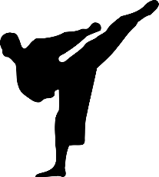
见面jiàn miàn = to see, to meet with
难过nán guò = to feel sad
打太极拳dǎ tài jí quán = to do tai chi
容易róng yì = easy
减肥jiǎn féi = lose weight (literally ‘reduce fat’)

小蓝很少有机会跟他家人一起见面，因为他天天在少林寺练功夫。
Xiǎo lán hěn shǎo yǒu jī huì gēn tā jiā rén yì qǐ jiàn miàn, yīn wèi tā tiān tiān zài shào lín sì liàn gōng fu.

可是小蓝不难过，因为他在少林寺有很多好朋友。
Kě shì xiǎo lán bù nán guò, yīn wèi tā zài shào lín sì yǒu hěn duō hǎo péng yǒu.

他的妈妈会打太极拳。她说太极拳很健康，可以很容易减肥。
Tā de mā mā huì dǎ tài jí quán. Tā shuō tài jí quán hěn jiàn kāng, kě yǐ hěn róng yì de jiǎn féi.
Questions on paragraph 2
- What does Xiao Lan rarely have an opportunity to do AND why?
- Why doesn’t he feel sad?
- What does his mother do?
- What does his mother say about tai chi apart from it being healthy?

Task 4 complete

(The text for this task is adapted from a teaching resource shared by TES user linboyuan)
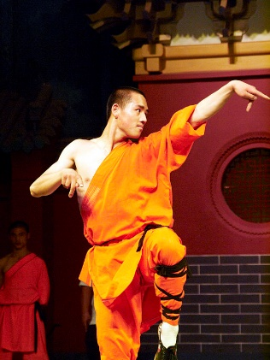
- Five Animals
Many Chinese movement forms like功夫, developed techniques based on the way some animals move. Particularly famous is the 五形wǔ xíng Five Animal fighting technique developed at 少林.
As you watch the following clip, note down below what the five animals of this combat style are. Then note down what other animal styles are mentioned apart from the Five Animals? REMEMBER: DO NOT TRY THESE MOVES UNLESS YOU ARE WITH A QUALIFIED INSTRUCTOR!
Watch from 25:05 to 29:27 (ignore the subtitles)
https://www.youtube.com/watch?v=3gPNRa15QhE

The Five Animals style
1.

2.

3.

4.

5.

Now look up the Chinese characters and the pinyin spelling for each animal you wrote down and copy the characters and pinyin next to the English word above.
Here is a short introduction to the Five Animals styles:
http://www.blackbeltmag.com/daily/traditional-martial-arts-training/kung-fu/the-5-kung-fu-animal-styles-of-the-chinese-martial-arts/
Each of the Five Animals has different characteristics as you are going to see. Look at this page, then write down the ‘trademark’ and any other features you like for each animal in the above grid you just filled in:
http://www.blackbeltmag.com/daily/traditional-martial-arts-training/kung-fu/the-5-kung-fu-animal-styles-of-the-chinese-martial-arts/
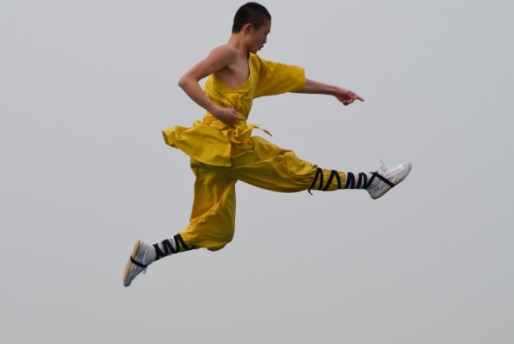

Task 5 complete

- Your thoughts about 功夫
Having found out a little bit about 功夫, write down your opinions about it in Chinese in the box below. For example, you could use觉得jué de, to say you find it interesting or exciting or scary, you could say that it is a healthy thing to do, or that it is harder than some other form of exercise: …比bǐ … 难nán. Or you might say that in the future you want to learn it. It is up to you what you write here.

Task 6 complete

- Locating Shaolin Temple
See if you can find out which province Shaolin Temple is located in. Then make a full sentence in Chinese to say, ‘Shaolin Temple is located in XXX Province.’ You will probably need to use the location word 在zài after the temple. Make sure you add the word for Province 省shěng after the province.
Answer: ______________________________________________
Next decide if you think that province is in the east, west north or south of China and make a sentence to say, ‘XXX Province is located in the XXX of China.’ The exact order of words in Chinese needs to be: ‘XXX Province + 在 + China + 的 + direction + 部bù (part)’

Answer: ______________________________________________
Kung Fu Challenge (optional)
Imagine you’ve booked a flight to Beijing but you still need to find out how to get from Beijing to 少林寺(Shaolin Temple). Research what sort of transport you need to take to get there and also how long it takes from Beijing. Tips: Use 坐zuò (to take/go by a form of transport) and 要 yào for how long it takes. For example:
从英国到德国坐飞机要一个半小时。From the UK to Germany by plane it takes one-and-a-half hours.

Answer: _______________________________________________________________________
______________________________________________________________
Task 7 complete

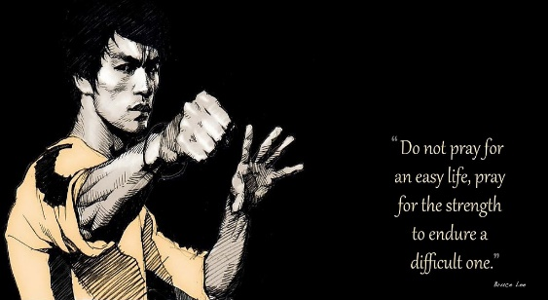
- Kung fu in the cinema
Bruce Lee
Thousands of 功夫films have been produced over the years. Two of the most famous actors ever to have starred in such films are Bruce Lee and Jackie Chan.
Bruce Lee died in 1973, but he still has a huge fan base. He was known to practice 5,000 punches a day and he took part in real fights off-screen as well. Some men chose to challenge him, but they all lost.
Jackie Chan
Jackie Chan has made over a hundred films and is loved both in Asia and the west. He performs all the dangerous stunts in his films himself and once he nearly died on set. Jackie is a real perfectionist and when shooting one film, he did 2,900 takes for just one ten-minute scene!

Speaking of 少林功夫, the comedy 少林足球 (Shaolin Soccer), starring the amazing Stephen Chow, has some hilarious scenes. Here’s one: https://www.youtube.com/watch?v=KEWUDWYDdYs
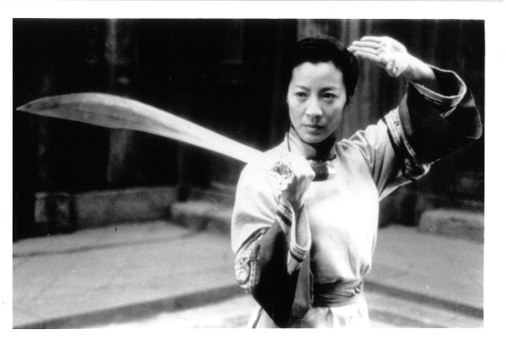
Michelle Yeoh
But big roles in 武术电影 are not limited to male actors. Films like House of Flying Daggers and Crouching Tiger, Hidden Dragon feature equally impressive actresses, such as Zhang Ziyi and Michelle Yeoh. Find out more about women in martial arts films here: http://mepstudents.edublogs.org/2017/02/23/the-first-ladies-of-kung-fu/

Take a look at the ‘identity cards’ below, one for Bruce Lee, one for Michelle Yeoh, and add the missing information. Work out what information is required (you might need to look up some words!) and find the answers online. Complete as many boxes as you can in Chinese (non-Chinese numbers are fine for the date).
Bruce Lee
中文名字：
zhōng wén míng zi

出生日期：____年___月____日
chū shēng rì qī

性别：
xìng bié

电影：(list two)

Michelle Yeoh

Task 8 complete
中文名字：
zhōng wén míng zi

出生日期：____年___月____日
chū shēng rì qī

性别：
xìng bié

电影：(list two)

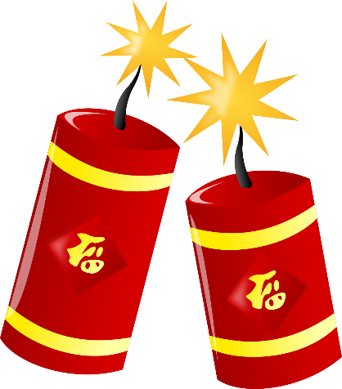
太棒了！

Well done!

Your Achievements
Congratulations on completing 1 MEP Project!

- You have delved into the exciting world of kung fu and come out alive.
- You have learned some cool new Chinese.
- You know where to find the Shaolin Temple. Let’s hope you don’t like it so much that you run away from the UK to become a young student there!

If you have time, do watch the rest of one of these two documentaries about life as a 少林功夫 student. They are truly fascinating. Here are the links again:

https://www.youtube.com/watch?v=SaFMkcsYJFw
https://www.youtube.com/watch?v=3gPNRa15QhE

See how this UK-born man became a martial arts actor, it may inspire you:
https://www.britishcouncil.org/voices-magazine/ted-duran-how-i-began-career-chinese-film-industry

There are lots of places around the UK where you can study different martial arts, so if you feel inspired, see if you can find one close to you to go and try out some moves!

If your teacher signs you off,
you will collect 1 Badge!

