My MEP Projects
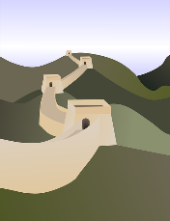

Project: The Great Wall
Project Series: History

Name: ____________________
The Great Wall of China is one of the most extraordinary feats of construction in the entire world. Building it took at least 2,000 years, and the wall itself is extremely long, as you are about to discover.

When you have finished this Project, you will know more than most people about the Great Wall. And your knowledge and excellent Chinese will add to your enjoyment when you visit it!

Tick the boxes as you complete the tasks.
Go for it!

- What’s in a name? A wall!

The Great Wall in Chinese is 长城 cháng chéng which means ‘Long Wall’.
It is also known as 万里长城 wàn lǐ cháng chéng, meaning ‘The 10,000 li Long Wall’. Li is a measurement used in ancient China, and one li is roughly 550 yards.
Write the characters 万 里 长 城 into the four bricks below. Then read them saying wàn lǐ cháng chéng out loud five times. Check the Strokes Order app before writing!

Task 1 complete

- The great story behind the wall
For this task you are going to read a short text about the history of the Great Wall and then you’re going to watch two short clips on YouTube. This is preparation for Task 3 when you will take a fun fact quiz. First, a text from the Encyclopaedia Britannica:
One of the largest engineering and building projects ever carried out is the Great Wall of China. Originally a defensive system, it is today a major tourist attraction and a national symbol of China. The Great Wall is actually not one wall but many different walls built over time in northern China and southern Mongolia. Some of the walls run parallel to each other.
The most extensive and best preserved version of the wall extends for some 5,500 miles (8,850 kilometres), often tracing the crest lines of hills and mountains as it snakes across the countryside. It extends from Liaoning Province in the east to Gansu Province in the northwest. Roughly 70 percent of the total length is constructed wall. Most of the rest consists of natural barriers such as rivers and mountain ridges, and a small portion consists of ditches and moats.
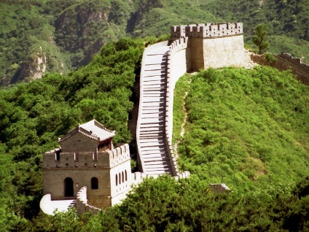
The walls were built over some two millennia. Various northern states built defensive walls in the 7th to 4th centuries BC. The earliest major work on a unified system came during the Qin Dynasty. The first Qin emperor, Shihuangdi, united seven different states into one China in about 221 BC. He ordered that some of the existing sections of wall be connected to form one long wall along the northern frontier, to protect the empire against invasions by wandering tribes from the north, especially the Xiongnu. The project began in about 214 BC and lasted about 10 years. The work was done by hundreds of thousands of soldiers and labourers who were drafted for the project.
Since that time the wall has been extended and rebuilt many times, and sections of it have fallen apart or been destroyed. Most of the wall that exists today was built in the 15th and 16th centuries, during the Ming Dynasty, to protect against Mongolian invasions.
The wall is simple in structure. Different sections were built of dirt, stone, or brick, depending on the local availability of materials. The height of the wall ranges from 15 to 30 feet (5 to 9 meters), with towers rising at regular intervals above it. The towers were used as watchtowers and signal towers. The wall is 15 to 25 feet (5 to 8 meters) wide. Along the top of some sections runs a 13-foot- (4-meter-) wide roadway. At strategically important points were built fortresses, known as passes, and gates.
The wall's use as a defensive barrier ended in 1644 with the collapse of the Ming Dynasty. Parts of the wall fell into disrepair, but in the 20th century it became a major world tourist destination and parts were restored. It was declared a UNESCO World Heritage site in 1987. Most tourists visit the sections near Beijing, especially at Badaling to the northwest of the city.

* * * * *

Now read the short news story from the BBC on the next page …

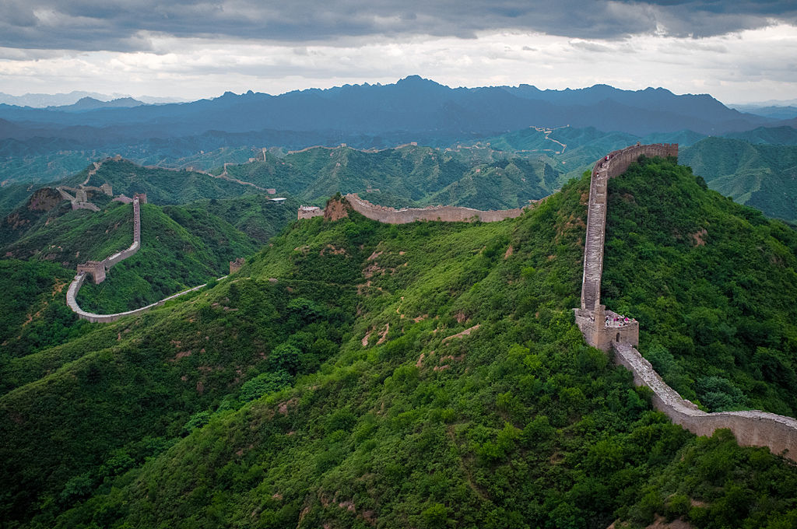

China’s Great Wall is ‘longer than previously thought’
6 June 2012

Bottom of Form
The Great Wall of China has been officially declared even longer than previously thought, state-run media report.
The wall measures 21,196.18km (13,170.6956 miles) long based on the latest state survey results, state-run news agency Xinhua reported on Tuesday. A preliminary study released in 2009 estimated the wall to be 8,850km long.
The world's largest man-made structure was built to protect China's northern border.
This is the first time such a definitive figure has been released, Xinhua reports.
The State Administration of Cultural Heritage released the results based on an archaeological survey done since 2007. Previous estimates of the wall's length were mainly based on historical records.
* * * * *
And finally, watch this cool video clip. Go to: https://www.youtube.com/watch?v=23oHqNEqRyo
(If you have problems with the shortened link, search directly in YouTube for ‘What makes the Great Wall so extraordinary’)
Task 2 complete

When you’ve read the articles and watched the film, tick:
- Fun Fact Quiz
Now that you have researched the Great Wall, see how many ‘bricks’ you can lay correctly, by circling a, b or c for each of these questions.

- What does the character 长 cháng mean?

a | great | b | long | c | wall

- What is the official rough length of the wall?

a | 21,196 km (13,171 miles) | b | 8,850 km (5,499 miles) | c | 12,018 km (7,468 miles)

- The Great Wall was originally designed to keep out …

a | any barbarians who might be trying to attack from the south or the north | b | the Xiongnu and the Mongolians | c | the Japanese, Koreans and Mongolians

- What is proof that helping to build the wall was not always fun?

a | Many labourers missed their families. | b | Many labourers died. | c | The money was not enough to live off.

- Who managed to invade China despite the wall?

a | Genghis Khan, founder of the Mongol Empire | b | Qin Shi Huangdi | c | The USA

- Is the Great Wall visible from space

a | You can see it from the moon. | b | You can see it from low orbit under certain conditions. | c | You can only ever see it from an aeroplane.

- What was used to communicate between different parts of the wall?

a | Pigeons carrying notes | b | Fire and smoke | c | Loud horns

- How has the world recognised the wall as a special place?

a | The UN and EU hold meetings there. | b | Many tourists come and take photos of it. | c | It’s a UNESCO World Heritage Site.
Task 3 complete

- Mapping the Great Wall
Search Google Images or an atlas for a map of the Great Wall. Using a coloured pencil or pen, copy the route of the wall onto the blank map of China below, adding in the cities, Beijing, Xi’an and Dunhuang (and others if you wish).

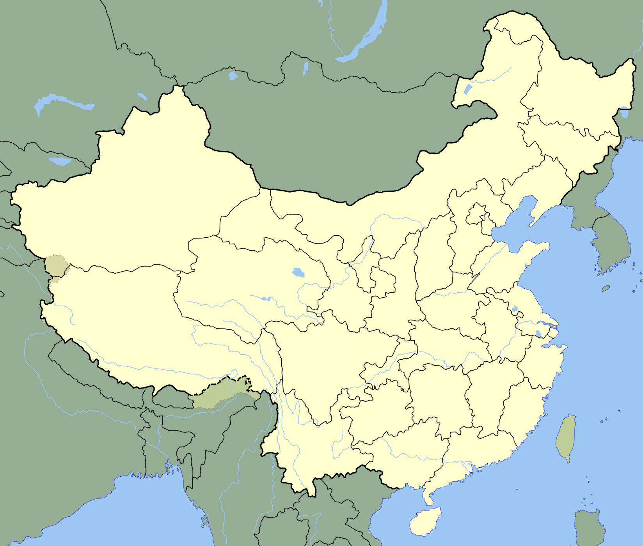

Task 4 complete

- Ooh, it’s just soooo pretty!
One of the best things about walking the Great Wall is the stunning views. So you need to get ready to admire the views in Chinese when you get there.
风
景
View is 风景 fēngjǐng. By the way, 风 doesn’t only mean ‘wind’. It can also mean ‘atmosphere’ or ‘style’.
景 means ‘scenery’ and it is part of a character you might have seen before, 影 from 电影. This is because jing and ying sound a little similar. Practise writing the two characters for ‘view’ in the boxes below:

See if you can translate the following two sentences into English. You can use apps or websites to help. Remember that 长城 chángchéng means ‘Great Wall’.
- 长城 的 风景 很 好看。Answer: _________________________________________.
- 风景 很 漂亮。Answer: _________________________________________.
Task 5 complete

- Now write these two sentences in Chinese characters. Tip: Don’t translate the words in brackets!

- I want (to) go (to) China (and) see (the) Great Wall.

- (The) UK’s scenery (is) also very beautiful. (If you have completed the diary project you will have learned also already)
的

Task 6 complete

- 214 BC – the year it all began
As you may know, China is the oldest continuous civilisation on earth. To give you an idea of the immensity of Chinese history, remember that the Great Wall was first built in 214 BC, shortly after China’s first emperor ‘Qin Shi Huangdi’ had united China and the Qin dynasty had begun. Well, it would be a long time before Britain was to be successfully united under one ruler like China already was.
Thinking of that year – 214 BC – look at the dates below and compare what was happening in China with what was happening in Britain. Then answer the three questions that follow.
Prehistoric Britain (5000 BC - c. 100 BC)
Britain before the Romans came: stone, bronze, iron ages, construction of Stonehenge, earthworks, Druids, the Celts.
Roman Britain (55 BC - 410 AD)
From Julius Caesar's first attempt at conquest to the final days of Roman administration in Britain: rebellion, subjugation, advent of Christianity, barbarian invasions, withdrawal.
Early British Kingdoms (410 - 598)
After the Roman influence ceased, the activities of the British people: westward movement, intrigues & alliances, power struggles, explosion of missionary activities, plague, Saxon invasions.

- When Qin Shi Huangdi ordered the construction of the wall to keep out invaders, what was the name of the historical period Britain was still in? ______________________________________
- Had Christ been born when the Great Wall was built? _____________
- The Qin dynasty was founded in 221 BC when China was united under one ruler. How many years after this did the Romans first attempt to invade Britain? _____________
Task 7 complete

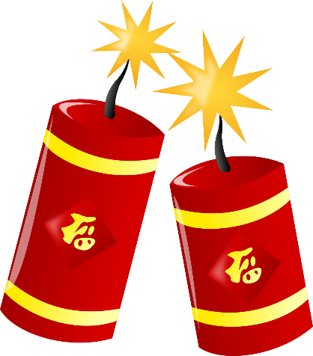
太棒了！

Well done!

Your Achievements
Congratulations on completing 1 MEP Project!

- You will never see the Great Wall with the same eyes again.
- When you walk on the wall, you will really appreciate all the hard work that went into making it.
- You know how ancient the wall is and you know that it was first built soon after China was unified under the First Emperor of the Qin dynasty.
- You can now enjoy saying the word 长城 chángchéng over and over again. It feels really nice to say it when you get the tones right!

List three things you would like to do when you first visit the Great Wall:

- _________________________________________
- _________________________________________
- _________________________________________

Now, reward yourself with this stunning clip of the Great Wall accompanied by music. These two musicians managed to get a grand piano all the way up onto the Great Wall!

Go to: https://www.youtube.com/watch?v=23oHqNEqRyo or search YouTube for ‘Kung Fu Piano’.

If your teacher signs you off,
you will collect 1 Badge!

