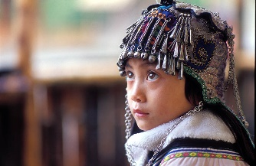
My MEP Projects
Figure 1: A child from the Hani group (not Han)

Project: The Peoples and Languages of China
Series: Geography

Name: ____________________
When you travel around China you will not only see many interesting things, you will also meet a wide range of people.

China is huge, so there are many languages and cultures all existing alongside each other in one country. This project introduces some of these languages and cultures.
Go for it!

- The Peoples of China

- Population
With close to 1.4 billion people (1.385 billion in 2016 to be precise), China has easily the largest population in the world. The word for population is 人口rén kǒu. Check you know the meaning of these characters. Think of this word as the number of mouths a ruler of a country has to feed to keep the nation alive.
First off, write out the characters above each pinyin word for this sentence, then translate it into English. Here duō (many) is used but dà (big) is also acceptable.
____ ____ ____ ____ ____ ____ ____
Zhōng guó de rén kǒu hěn duō
Translation: ___________________________________________
Task 1 complete

- Who is truly ‘Chinese’?
The population may be mammoth, but how many people are really Chinese? And how do we define ‘being Chinese’ in the first place? There is one ethnic group that is far bigger than all the others. Find out which one it is by visiting the Wikipedia page below:
https://en.wikipedia.org/wiki/List_of_ethnic_groups_in_China
Answer: ________________
As you can see, the people of this huge ethnic group make up almost 92% of all people living in China. They are actually named after a dynasty. If you have done one of the history projects, you may remember the name of the first dynasty that united China. Yes, it was the Qin dynasty and it only lasted from 221 to 206 BC, that’s just fifteen years. Well, the Han dynasty began straight after it and lasted a good deal longer, from 206 BC to 220 AD, that’s 414 years!
The Han dynasty was considered a golden age in the development of China, and that is why the people were named after it. So was their language, which apart from 中文is also called 汉语hàn yǔ. The Chinese characters that you are learning and that have been so important in helping people from different parts of China to communicate over the centuries are Han characters, or 汉子hàn zì.
In reality, it is difficult to say that any Chinese person is 100% Han because over the centuries people from many different tribes and cultural groups became part of the general Han group, just like in Britain it is difficult to say anyone is 100% British, English or Scottish, as there are many groups who formed the nation we know today, e.g. the Celts, the Vikings, the Romans, the French, the Anglo-Saxons etc.

Other groups
Including the Han, the People’s Republic of China recognises many other ethnic groups. Look at this cute map and see if you can count how many groups there are in total:
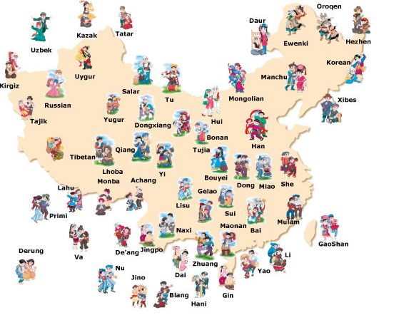

Now look back at the full list of ethnic groups on the Wikipedia page you just visited to see if you counted correctly.
On the Wikipedia page, scroll down to the section entitled ‘Ethnic groups recognised by the People’s Republic of China’. Note down how many are there including the Han here:_________.
The character 族zú is used to mean ‘clan’, ‘tribe’, ‘ethnic group’ and ‘nationality’. Check the Wikipedia page again and copy out some of the information about the four largest groups into the grid below. Be sure to include the character 族 in the name.

English name | Pinyin | Characters  (include 族) | % of population in 2010 to 1 decimal point | Size (number) of population in 2010
Task 2 complete

- Chinese Ethnic Minorities

We’re now going to get to know four ethnic groups in a bit more detail. They are the Miao, Zhuang, Hui and Uyghur.
Take another look at the map image where you counted the little pictures of the different ethnic groups and see if you can find where these four tribes are located, for example one might be in western China, one might be in the south, another might be in the southeast.
In a moment you are going to complete the Chinese sentences below so that they describe where each of the four groups are based. If you have done the other geography project already, you will have learned directions. If you haven’t done it, or if you need a little practice, here’s a reminder of directions in Chinese:
The four directions are 东dōng,西xī,南nán, and北běi. Complete the table on the next page. If you’ve done this before, it’s going to be very good practice for you. You might need to use a dictionary, especially if you are new to directions. Practise writing the character for each direction in the three extra boxes.
汉子 | 拼音 | English
东 | dōng
西 | xī
南 | nán
北 | běi

The Zhuang sentence has been completed for you as an example. You can copy everything after 在 and just change the direction word. Remember that 部 at the end just means ‘part’ or ‘region’.
- Zhuang:壮族居住在中国的南部。
Zhuàng zú jū zhù zài zhōng guó de nán bù .
The Zhuang live in the south of China. (literally ‘Zhuang group dwells in China’s southern part.’)

- Miao: 苗族居住在_______________

- Uyghur: 维族居住在_______________

- Hui: 回族居住在___________________
So, who are these interesting peoples? Let’s find out more in the next task …
Task 3 complete

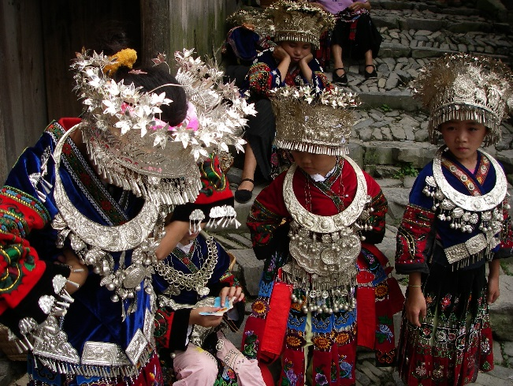
- The Miao and Zhuang
Most Miao live in the mountains in the south of China in such provinces as Hunan, Yunnan, Sichuan and Guangdong. Miao people speak a number of different languages as there are many different groups of Miao. Why do you think these different languages and groups of Miao might have been formed?
Answer: ____________________________________________________
Figure 2 Miao Girls; Attributed to L Bit; https://commons.wikimedia.org/wiki/File:Lang_De_Girls.jpg

If you guessed that it was because the groups of people were isolated from each other by mountains, you were probably right.
Unlike other ethnic minorities, quite a few Miao have also emigrated to other countries. Here’s an interesting fact about the Miao: they love silver. But more on that in the video below!
As you will have noticed from Task 1, the Zhuang are China’s largest ethnic group apart from the Han. Like the Miao, they have a number of different languages and can only understand other Zhuang people who speak the same variety. But they can usually use some form of Chinese to communicate with each other.
Watch a bit of the following two clips and make notes below about anything you find interesting.
Warning: the subtitles in the Miao film are a little odd and the English in the Zhuang film is strange. That doesn’t matter. The main thing is that you see how different groups can be from each other.
Miao: https://www.youtube.com/watch?v=9BMPVRsKo6Y
Zhuang: https://www.youtube.com/watch?v=ipSkiyyISVE
On the next page there is a box for you to write down any thoughts about the Miao and Zhuang, e.g. about their different clothing. You may also spend a few minutes researching them online or reading about them on Wikipedia.
Your thoughts about the Miao and Zhuang

Task 4 complete

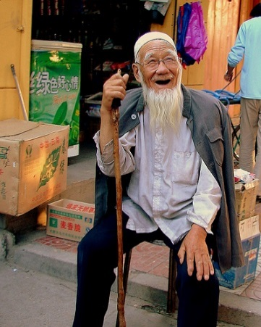
- The Hui and Uyghur
Another very interesting group is the Hui. Watch this short visual documentary about the Hui group and answer the questions that follow. You only need to watch up to 3:14.
https://www.youtube.com/watch?v=uJVk8BgezpU

- A lot of people think of China as being either Buddhist or Communist. In fact there are lots of different belief systems alive in China today. What religion do you think the Hui follow?

- Looking at the writing in the film, is it the same as Chinese? What do you think it could be?

- What do you notice about the rooftops on the religious buildings?

The Hui have been a part of Chinese society since the Tang Dynasty (over 1300 years ago!), when traders came from the Middle East to do business in China. They are quite integrated in Chinese culture, and mainly speak Chinese language. This is different to Uyghurs, another group in China. See if you can find out about the Uyghurs, where they live and their culture, by reading here and answering the questions below: https://en.wikipedia.org/wiki/Uyghurs
- What province do Uyghurs mostly live in? Mark it in on the map. What countries does it border?

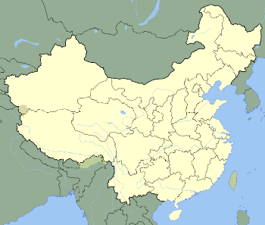
- Approximately how many Uyghurs live in China?

- What language do they speak? Where do you think this language originally came from?

Have a look at the photos below from the best Sunday market in the world- and a place to meet lots of Uyghur sellers- the Kashgar Great Bazaar! What can you see? Would you like to go? What would you buy? Try and answer in Chinese!

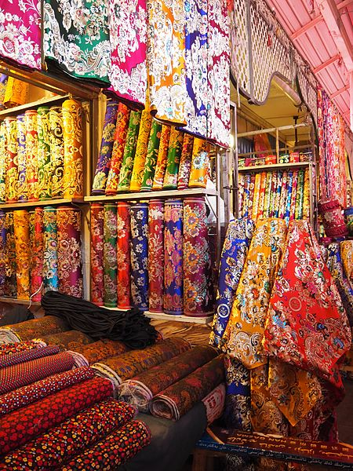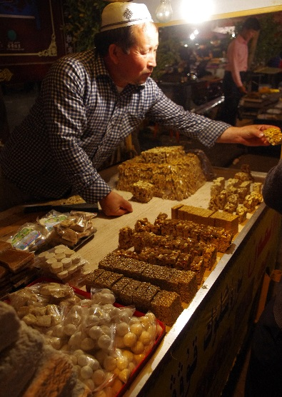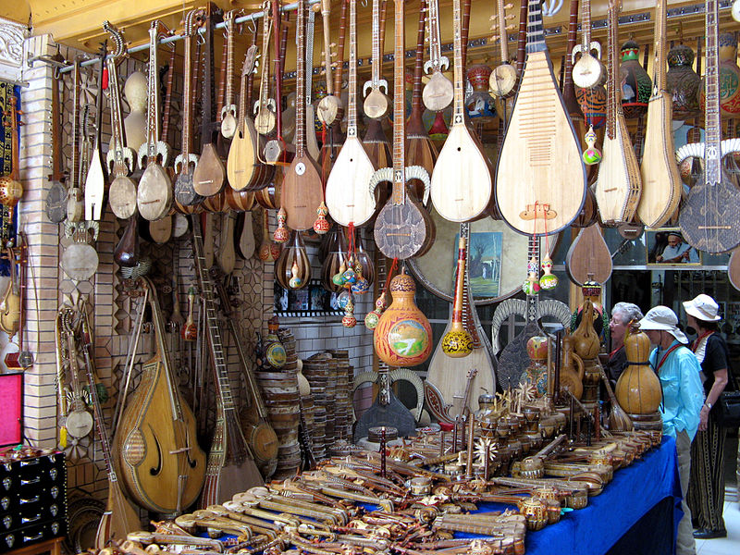

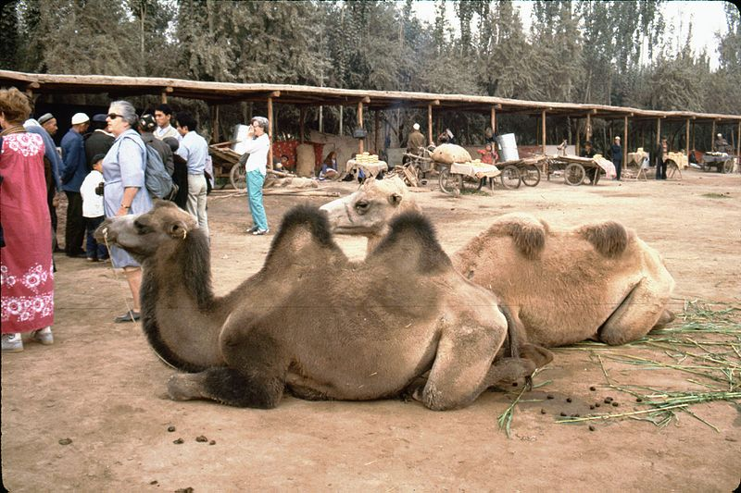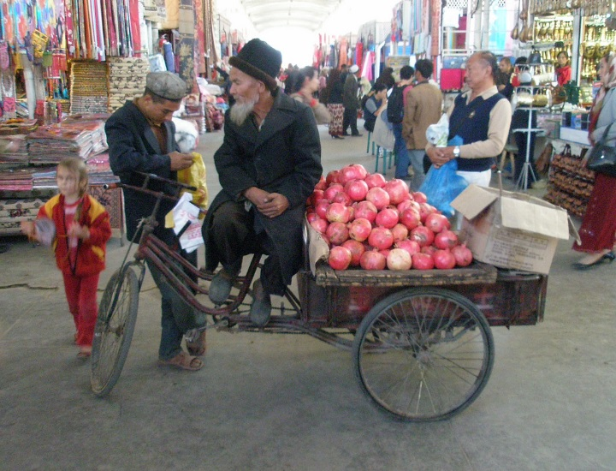
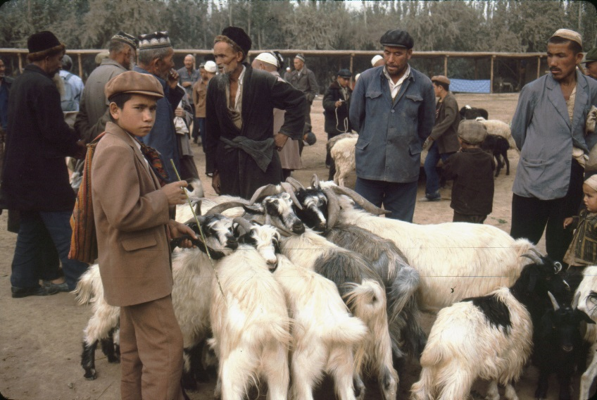
我会看。。。

我要买。。。

我要/不要去。。。

If you want to read more about this amazing market, check out this link:
https://www.timetravelturtle.com/grand-bazaar-kashgar-china/
Task 5 complete

- The Languages of China

- The benefit of learning Mandarin
There are many varieties of Chinese, such as Cantonese, Shanghainese, Min, Sichuanese and of course Mandarin.
You’re lucky to be learning Mandarin. Most Chinese people you encounter in your life will be able to understand this language, even those who don’t speak it confidently. So you clearly picked the right tongue.
Have a look at the map at the following link to see just how widespread Mandarin is in China:
https://upload.wikimedia.org/wikipedia/commons/5/55/China_linguistic_map.jpg
Based on this map, can you make a general conclusion about which areas Mandarin is spoken in?
Answer: _______________________
Contrary to the colour of the island Taiwan on the map, Mandarin is also widely spoken in Taiwan, where it is called 国语guó yǔ, which would be what in English? ______________________
Do you remember how else to say ‘Chinese’ in Chinese? That’s right, it’s 中文zhōng wén or 汉语hàn yǔ. But it is also known as 普通话pǔ tōng huà. Look up 普通 and 话. Why do you think this word is used for Mandarin?
Figure 3: Taiwan singer Jay Chou is popular throughout China. Most of his songs are in Mandarin, which is the main language in media, government, education and increasingly in business.
Answer: _____________________________________________

You now know 3-4 ways to say Mandarin – give yourself a pat on the back!

Using the word ‘pǔ tōng huà’, complete the following sentence so that it means, ‘I can speak Mandarin.’
____ 会说____ ____ ____。(会说huì shuō = can speak)

You’re now going to learn how to say, ‘Apart from .., I (can) also …’ in Chinese, and this will be so useful to you when it comes to writing your homework later on.
‘Apart from’ is 除了chú le.
了is not a past tense here, but it used together with 除 to mean ‘apart from’.
The pattern you need is:
除了(chú le) noun 1 , subject 还(hái) verb + noun 2
Helpful to know: this pattern can also be used with verbs, with verb 1 and verb 2 replacing the nouns.
还hái means ‘also’. You can use 也 in place of 还 but for this project, let’s give 还 a go.
For example, 除了游泳，我还喜欢看书。= Apart from swimming I also like reading.
See if you can use the same pattern to write, ‘Apart from Mandarin (普通话), I can also can speak English.’

Answer: _________________________________________________________

Good work! Now to make sure you practise using it, make one about hobbies like the example sentence above using 喜欢. Choose your own hobbies or sports.

___________________________________________________________
Task 6 complete

- Mandarin knowledge quiz
You have seen that Mandarin is a great choice of Chinese language to learn. Let’s take this opportunity to check how many characteristics of this language you have mastered already. Circle a), b) or c) for each question.
- Which of the these is NOT a way to say ‘Mandarin’ ?
- 汉语 | - 英文 | - 普通话
- How many tones are there in Mandarin, including the ‘toneless’ tone?
- 5 | - 6 | - 4
- What are the two main types of characters known as?
- basic and advanced characters | - simplified and complicated characters | - simplified and traditional  characters
- What is the part of a character called that tells us the meaning of that character, e.g. 木(wood) or 女(female)?
- the wise part | - the dictionary definition | - the radical
- What is the part of a character called that tells us the sound of that character, e.g. 且 in 姐姐?
- the radical | - the pronounced part | - the phonetic
- How can Chinese be written?
- left to right or top to bottom | - left to right only | - left to right, top to bottom and right to left
- How should the verb 是shì ‘to be’ be used?
- It can be used just like in ‘to be’ in English | - It can only be used with nouns, e.g. 他是老师 = he is a teacher | - It should only be used with adjectives, e.g. 你是漂亮 = You are pretty
- How is 和hé used?
- It means ‘and’, e.g. 我去买东西，和我买了电视。 = I went shopping and I bought a TV. | - It means also, e.g. 我和喜欢她。= I also like her. | - It means ‘and’ and is generally used to link nouns.
Task 7 complete

- Other Chinese languages
Visit the following page and choose two Chinese languages that are not Mandarin to read about. Make a few short notes about where it is spoken and any other points of interest in the box below the link.
http://www.omniglot.com/chinese/spoken.htm

Name of language
Where it is spoken
Other notes

Name of language
Where it is spoken
Other notes

Task 8 complete

- So many ways to say things!
Watch 高老师 (Mr G) chatting away about different Chinese languages and also regional differences of Mandarin. Make notes on anything you find interesting in the box below.
https://www.youtube.com/watch?v=Cwc294ONQLM

Task 9 complete

- Counting from 1 to 10
Have some fun trying to count from one to ten in Cantonese, Hakka and Shanghainese with these YouTubers:
Cantonese: https://www.youtube.com/watch?v=tjgX94gWcIk
Hakka: https://www.youtube.com/watch?v=LLePMGEYabg
Shanghainese: https://www.youtube.com/watch?v=aGbIjLD9IIE
Task 10 complete

- Video time!
Check out this video where you can hear 29 different Chinese dialects:
https://www.youtube.com/watch?v=BcbAV7PJN_c
And now, enjoy this really funny one about the different ethnic groups in China:
https://www.youtube.com/watch?v=uOH55UlDq6A
Task 11 complete

太棒了！

Well done!

Your Achievements
Congratulations on completing 1 MEP Project!

- You now know that ‘being Chinese’ is not as easy to define as many people might think. You understand that there is a wealth of different languages and cultures in China.
- You know that Mandarin can be spoken in a range of different ways depending on where in China you go.
- You won’t be as surprised when you hear different Chinese languages.
- You can have confidence that you picked the best Chinese language to learn as almost everybody in China understands Mandarin.

Name one group of people in China that you might like to visit one day:

_________________________________________

If your teacher signs you off,
you will collect 1 Badge!

