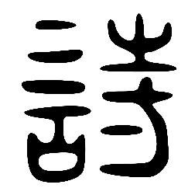
My MEP Projects
An old version of the character for poetry: 诗 shī

Project: Tang Poetry and a Short Story
Series: Culture
Name: ____________________
As your Chinese skills develop, you will find your confidence grows. Bit by bit, you can begin to read whole poems and stories in Chinese, even if only slowly at first. But practising this makes your ‘Chinese mind’ think more like a native speaker’s. Yeah!

By choosing this Project you are proving what a true legend of a Chinese student you are. So you deserve a big well done upfront. You will get some real satisfaction out of this Project as solving the mysteries of translation can feel amazing.

Go for it!

- Setting the Path of the Word Wizard
Art and poetry is very important in Chinese culture- both ancient and modern. Before you can tread the path of the great Chinese poets, you need to equip yourself with the word wizards’ eye for detail and emotion. Below is a traditional Chinese landscape painting. These are called 山水画shān shuǐ huà in Chinese. What is that translated literally into English?
Answer: ____________________________________
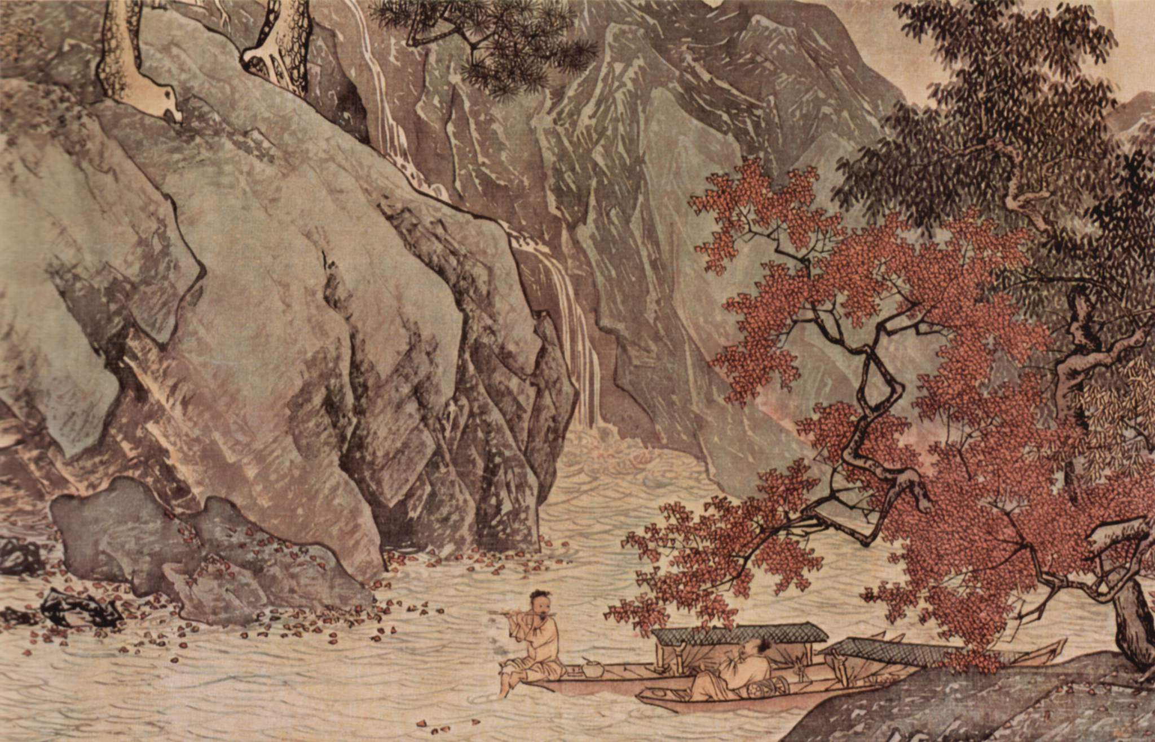
Look carefully at the painting, then take up your brush (or rather pen!) and follow the instructions on the next page.

Fisherman on the River in Autumn by Tang Yin (1470–1524)
You will find a scroll below. In it you need to write down in Chinese what you can see in the picture. Here are some useful words to help you:
条tiáo = measure word for rivers and small boats
棵kē = measure word for trees
吹chuī = to blow, to play a wind instrument

Use a dictionary or the internet to help you find more words (for example, fisherman, river, boat, tree, flute, rocks).

Then write a sentence in Chinese saying what you like about it. Lastly, write one sentence about how the picture makes you feel. You can begin your sentence with 我觉得 (wǒ jué de I think/ feel) or 这幅画让我觉得 … (zhè fú huà ràng wǒ jué de … = This picture makes me feel …). if you have completed the Youtube Project, you can reuse some of the language you learnt there.

On the next page there is another stunning 山水画. Do the same again with the scroll that follows it. By saying what you see, like and feel, then, young Word Wizard, you will be ready for your first poem.

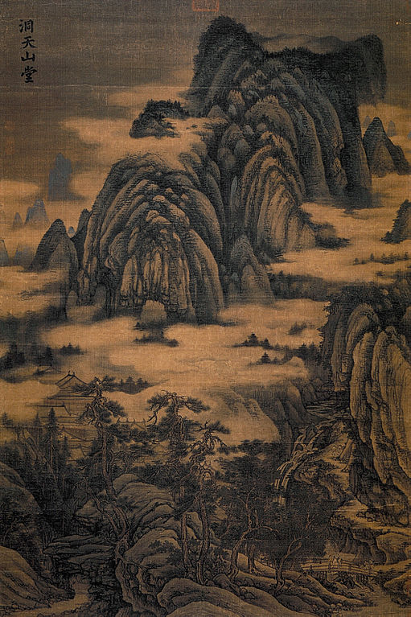

Task 1 complete
Dongtian Mountain Hall by Dong Yuan (ca.934-962)

- So what is so famous about Tang Dynasty poetry?
You are now ready to dive into some Chinese poetry, but first, who were these poets? Use this link to read a little bit about Tang Poetry and write down the names of five famous poets:
https://www.travelchinaguide.com/intro/literature/classical2.htm
(you can also ask your teacher, or a Chinese person because they might know- they are very famous!)
Answer (in English):
- _________________________
- _________________________
- _________________________
- _________________________
- _________________________
Task 2 complete

- Poetic gems
You are ready at last to take a look at two short Chinese poems written in the Tang Dynasty (618 – 907 AD). Some of China’s most famous poetic works were written at this time and even today many Chinese people learn them and love them. This type of poetry is written in what is known as Classical Chinese and some characters can have meanings that are slightly different to their meaning today.
Classical Chinese poetry is famous for saying a lot in very few characters. We are going to look at the shortest form of Tang poem: the five-syllable, four-line poem.
Watch the first 13 seconds of this clip about a four-line poem by Li Bai, China’s most famous Tang poet. This one is only four lines long! The characters in the video are traditional, so a simplified version is provided below for you. Be sure to stop the video after 13 seconds. Don’t cheat! You’ll see why in a moment. Turn to the next page when you have done this.
https://www.youtube.com/watch?v=82jcwYdKPTY

静夜思Jìng yè sī Thinking On a Quiet Night
李白(By) Lǐ bái (701-762 AD)

Chinese Your Translation
床 前 明 月 光
chuáng qián míng yuè guāng

疑 是 地 上 霜
yí shì dì shàng shuāng

举 头 望 明 月
jǔ tóu wàng míng yuè

低 头 思 故 乡
dī tóu sī gù xiāng

Exploration time!
Use Pleco or an online dictionary to look up any words you don’t know and see if you can work out what each line means. Right your answer in the space to the right of the poem. Don’t worry about being perfect, just see what you can come up with.
When you have finished all four lines, watch the rest of the video to see how close your translation is to the original. Make a few notes below on what you found easy, strange or difficult and tell your teacher. Congratulations! You have now mastered translating a poem!

Notes:

Task 3 complete

- Get to know the author
For our next and final four-line poem, you’re going to find out a bit about the poet first. Only watch the first 37 seconds to start with and complete the grid below, pausing the video when you need to. Here is the link, but remember to only watch until 0:37.

https://www.youtube.com/watch?v=SZdb8_x93gQ

Write down the characters and pinyin for the name of this poet

The second character of the name was written as a traditional character. Use this link to find the simplified version of this character http://www.newworldencyclopedia.org/entry/Wang_Wei_(eighth_century_poet)

When did they live?

What was their profession?

What was their religion? Write your answer in both English and Chinese (you might need a dictionary!)
Write down the name of this poem in characters, pinyin and English

Did this poet live in the city or the countryside? Write your answer in Chinese.

Task 4 complete

- Have a go!

Now, looking at the glossary, have a go at translating the poem, not worrying if it is perfect or not, just enjoying being creative with language. Write your translation to the right of each line.
Chinese Your Translation
空山不见人
kōng shān bú jiàn rén

但闻人语响
dàn wén rén yǔ xiǎng

返景入深林
fǎn jǐng rù shēn lín

复照青苔上
fù zhào qīng tāi shàng

Glossary
闻 wén to hear
返 fǎn to return
景 jǐng brightness, reflection, late sunlight
复 fù again
苔 tāi moss
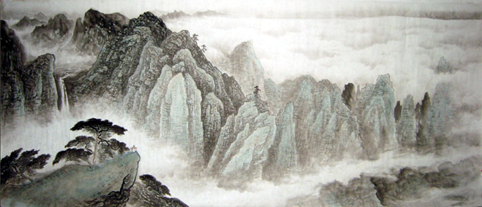
When you’ve finished, watch the ‘Learn Chinese Now’ presenter explaining the poem and translating it. Make any changes you want.
https://www.youtube.com/watch?v=SZdb8_x93gQ

Task 5 complete

- 你是 ...？And you are … ?
We now turn to an awesome short story about the morning adventures of a boy called 小明Xiǎomíng. Your task is to translate the story so that it makes as much sense as possible in English. You can then show off your skills by reading the English version out loud to a family member and claim it as your own translation.
Let me tell you about ‘compound words’. Most Chinese characters do have a meaning when used alone. But characters (most frequently two of them) are often combined to form a meaning. E.g. 广 guǎng means wide/extensive, 告gào means announce/tell. Together as 广告 they mean advertisement, because something is being ‘widely announced’.

The first line has been translated (in bold font) already, but the rest needs your help. Sometimes the pinyin from two characters has been combined to form a compound word as this will make it easier for you to look up that word in the dictionary.

There are three mini sections to this story, the first one being 第一天dì yì tiān – Day One.

First, study the glossary (for all underlined words in the story):

走路zǒulù = to go by foot, go on foot
在路上zài lù shang = on the way
看到kàndào = to see, saw, catch sight of
条tiáo = measure word for trousers or skirts
件jiàn = measure word for upper body clothing, e.g. a jacket
要yào = need to, have to (but notice that sometimes it also means ‘want to’)
啊呀āyā = Oh!, Hey!
然后ránhòu = then
幅fú = a measure word for pictures or paintings
吧ba = used to suggest something, e.g. 吃饭吧! = Let’s eat!

的时候de shíhou = ‘When …’. This is a really useful way to say, ‘When I was (e.g. eating or walking) …’ followed by something else happening. You will be practising this a lot for GCSE. Here are two examples:

她喜欢吃饭的时候听音乐。 = She likes to listen to music when she eats.

Notice that的时候de shíhou has to go after the thing you are saying (I was eating when, …) ‘when’ about, unlike English (‘When I was eating, I …).

Try translating the next example into English:

昨天我和妈妈买东西的时候，看到了我的中文老师。

Answer: _______________________________________________________

不要bú yào = No need to; Don’t!

Tip: Try not to translate too literally or keep the same word order as that can sound really strange.
Key: Sometimes you will need to change the word order or add or subtract a few words to make it sound like proper English!

Compile your own study log
Make sure you have an extra sheet of paper or your exercise book handy. You will probably need to look up a few words while you translate. Write each of them down separately (characters, pinyin and English). Then, try making a sentence with each new word. Show your teacher your efforts by handing in the sheet/book with this Project at the end.

Let the story begin!

你是 ...？And you are … ?

第一天Dì yì tiān – Day One

因为 小 明 的妈妈去医院看病，所以小明走路去学校。
Yīnwèi xiǎo míng de māma qù yīyuàn kànbìng, suǒ yǐ xiǎo míng zǒulù qù xuéxiào.
Because Xiaoming’s mother was going to the hospital to see the doctor, he went to school on foot.

他在路上看到了公共汽车站前边有一个很高的女学生。
Tā zài lù shang kàndào le gonggòng qìchē zhàn qián bian yǒu yí gè hěn gāo de nǚ xuésheng.

她穿一条黄色的裙子和一件蓝色的衬衫。
Tā chuān yì tiáo huángsè de qúnzi hé yí jiàn lánsè de chènshān.

小明很喜欢她。小明说：“你去学校吗？”
Xiǎo míng hěn xǐhuan tā. Xiǎo míng shuō: “Nǐ qù xuéxiào ma?”

她说：“对，你呢？”
Tā shuō: “Duì, nǐ ne?”

小明说：“我也去学校。你上什么课？”
Xiǎo míng shuō: “Wǒ yě qù xuéxiào. Nǐ shàng shén me kè?”

她说：“我上美术课。啊呀！公共汽车来了，我要走。再见！”
Tā shuō: “Wǒ shàng měishù kè. Āyā! Gōnggòng qìchē lái le, wǒ yào zǒu. Zàijiàn!”

然后，她上车了。小明喜欢她，所以他去商店买了一幅画给她。
Ránhòu, tā shàng chē le. Xiǎo míng xǐhuan tā, suǒyǐ tā qù shāngdiàn mǎi le yì fú huà gěi tā.

第二天

吃早饭的时候，小明说：“妈妈，不要开车了，我要走路去学校。”
Chī zǎofàn de shíhou, xiǎo míng shuō: “Māma, bú yào kāi chē le, wǒ yào zǒulù qù xuéxiào.”

他走路去公共汽车站，看到了那个女学生。
Tā zǒulù qù gonggòng qìchē zhàn, kàndào le nà gè nǚ xuésheng.

他说：“你好！我买了一幅画，你要吗？”
Tā shuō: “Nǐ hǎo! Wǒ mǎi le yì fú huà, nǐ yào ma?”

女学生说：“你是谁？去吧！我不认识你。”
Nǚ xuésheng shuō: “Nǐ shì shéi? Qù ba! Wǒ bù rènshi nǐ.”

小 明 很 不 开 心。
Xiǎo míng hěn bù kāixīn.

第三天

小明和妈妈一起开车去学校的时候，他看到两个
Xiǎo míng hé māma yì qǐ kāichē qù xuéxiào de shí hou, tā kàn dào liǎng gè

女学生站在公共汽车站前边。
nǚ xuésheng zhàn zài gong gòng qì chē zhàn qián bian.

她们都穿一条黄色的裙子和一件蓝色的衬衫。
Tā men dōu chuān yì tiáo huángsè de qúnzi hé yí jiàn lánsè de chènshān.

小明说：妈妈，我知道了！不要开车了，我要走路。”
Xiǎo míng shuō: Māma, wǒ zhī dao le! Bú yào kāichē le, wǒ yào zǒulù.”

他走路去公共汽车站的时候，一个女学生说：“早上好，
Tā zǒulù gonggòng qìchē zhàn de shí hou, yígè nǚ xué shēng shuō: “Zǎo shang hǎo,

昨天我想你。这是我妹妹。我们是双胞胎。”
Zuó tiān wǒ xiǎng nǐ. Zhè shì wǒ mèimei. Wǒ men shì shuāng bāotāi.”
Task 6 complete

太棒了！

Well done!

Your Achievements
Congratulations on completing 1 MEP Project!

- You know about the beauty and simplicity of Tang poetry.
- You have translated an entire short story from Chinese with very little vocab provided.
- You have looked up and learned some brand new words you didn’t know before.
- You know what a compound word is.
- You are ready to take on anything your Chinese teacher gives you to do.
- You have hopefully dramatically improved your confidence in your translation skills

Now why not take a look at one or two of the stories on this brilliant website that shows the meaning of each character and compound word if you hover it with your mouse!?

http://chinesereadingpractice.com/category/beginner/childrens-stories/

If your teacher signs you off,
you will collect 1 Badge!

