Jinbu 1 Unit 1 End of Unit Assessment
Listening
You will hear each question twice.
1. Dictation – Write the English for each of the Chinese words you hear. (5 marks)
a) 忙 – busy
b) 我 – I/Me
c) 六十二 - 62
d) 好 - good
e) 叫 – to be called
2. Dictation – Write the Chinese character and pinyin for each English word you hear. (10 marks)
 | Chinese character | Pinyin
a) | 岁 | Sui
b) | 多 | Duo
c) | 很 | Hen
d) | 老师 | Lao shi
e) | 她 | ta

3. Listen and decide whether the statements are true or false. If false put a against the statement, if true put a . (8 marks)
Statement | /
1. The conversation is between two friends.
2. The conversation is taking place in the morning.
3. This person is introducing himself.
4. This person is introducing herself.
5. This is a teenager introducing himself.
6. This is a teenager introducing herself.
7. This person is asking for someone’s name.
8. This person is greeting someone.
4. Listen and write the age of each person in English. (4 marks)
Person | Age
Lanlan
Scott
Mei Fang
Mark

Reading
1. Read the sentences and choose the correct English translation. （6 marks）
1. 我十岁。
a) I am 11 years old. b) I am 10 years old.
2. 他十九岁。
a) He is 19 years old. b) He is 17 years old.
3. 我叫Robert。 他叫John。
a) He is called John and I am called Robert. b) I am called John and he is called Robert.
4. 你十八岁， 我十六岁。
a) You are 18 years old and I am 16. b) I am 18 years old and you are 16.
5. 他五岁， 他叫Simon。
a) I am 5 years old and I am called Simon. b) He is 5 years old and he is called Simon.
6. 她十二 岁， 他二十岁。
a) She is 12 years old and he is 20. b) She is 20 years old and he is 12.

2. Match the Chinese to the English. Write the number of the correct Chinese that matches. (8 marks)
1. 你好 2. 早上好 3. 他 4. 她
5. 十 6.十九 7. 二十 8. 十七
English | Number
a) 17
b) he
c) hello
d) good morning
e) she
f) 19
g) 10
h) 20

3. Read the Chinese and decide if the English translation is correct. If correct put a in the box, if incorrect put a in the box. (8 marks)
/
1。早上好 Good morning.
2。 老师好 Goodbye.
3。 九十四 93
4。 再见 Hello
5。 我三十一岁。I am 31 years old.
6。 她六十岁。She is 60 years old.
7。你好吗? Are you busy?
8。 我不很忙。I am not very good.

4. Translate the following from Chinese to English. (4 marks)
1. 我叫Jade, 我八岁。

2. 我叫Manpreet, 我十二 岁。

3. 你好，我叫Anya, 我十四 岁。

4. 早上好！我叫Marie, 我十 五岁。他叫Ian, 他十 六 岁。

Writing
1. Write the Chinese and pinyin for the following numbers. (16 marks)
 | Chinese | Pinyin
a) 5
b) 13
c) 38
d) 9
e) 76
f) 14
g) 10
h) 25

2. Write the Chinese and pinyin for the following words and phrases. (10 marks)
 | Chinese | Pinyin
a) good bye
b) hello teacher
c) what?
d) how old are you?
e) years old

3. Complete the following phrases/sentences with the appropriate character. (5 marks)
1. ______ 上好。
2. 我 ______ Robert。
3. 你好 ______ ?
4. 忙 ______ 忙？
5。我很好， 你_____？
4. You are the highlighted person in each group. Introduce what you are called and how old you are. Then introduce each of your friends giving their name and age. Write in Chinese characters. (24 marks)

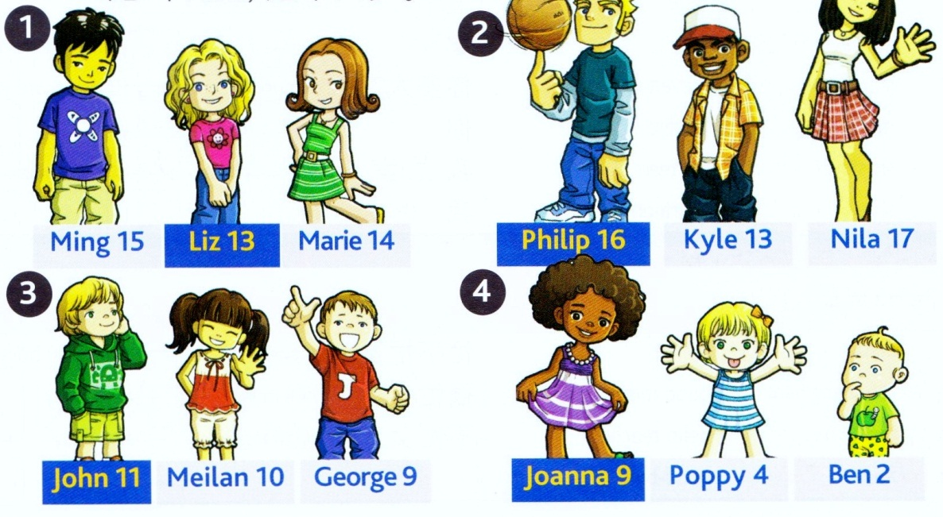
1.________________________________________________________________________
__________________________________________________________________________
__________________________________________________________________________

2.________________________________________________________________________
__________________________________________________________________________
__________________________________________________________________________

3.________________________________________________________________________
__________________________________________________________________________
__________________________________________________________________________

4.________________________________________________________________________
__________________________________________________________________________
__________________________________________________________________________

